FARM-2-MARKET


By:

Shahid Abbas
13434
Ehtesham Haider
21589

Supervised by:
Mr. Shabbir Hassan

Faculty of Computing
Riphah International University, Islamabad
Spring 2023
A Dissertation Submitted To

Faculty of Computing,
Riphah International University, Islamabad
As a Partial Fulfillment of the Requirement for the Award of the Degree of
Bachelors of Science in Software Engineering

Faculty of Computing
Riphah International University, Islamabad

Final Approval

This is to certify that we have read the report submitted by Shahid Abbas (13434), Ehtesham Haider (21589) for the partial fulfillment of the requirements for the degree of the Bachelors of Science in Software Engineering (BSSE). It is our judgment that this report is of sufficient standard to warrant its acceptance by Riphah International University, Islamabad for the degree of Bachelors of Science in Software Engineering (BSSE).

Committee:

1 | Muhammad Shabbir Hassan  (Supervisor)
2 | Dr. Muhammad Zubair  (Head of Department/chairman)

Declaration

We hereby declare that this document “Farm-2-Market” neither as a whole nor as a part has been copied out from any source. It is further declared that we have done this project with the accompanied report entirely on the basis of our personal efforts, under the proficient guidance of our teachers especially our supervisor Muhammad Shabbir Hassan. If any part of the system is proved to be copied out from any source or found to be reproduction of any project from anywhere else, we shall stand by the consequences.

___________________________
Shahid Abbas
13434

___________________________
Ehtesham Haider
21589

Dedication
We dedicate our work to our family, friends and teachers. The supreme encouragement from our parents and exceptional support from teachers is what lead to success of this project. We also dedicate our work to our supervisor Muhammad Shabbir Hassan whose continuous support and guidance helped us convert our idea into reality.
Acknowledgement

First of all we are obliged to Allah Almighty the Merciful, the Beneficent and the source of all Knowledge, for granting us the courage and knowledge to complete this Project.
We are grateful to our parents for the love and encouragement they provided us throughout the project. Also, a special thanks to all the faculty members especially our supervisor Respected Muhammad Shabbir Hassan for their guidance and support.

___________________________
Shahid Abbas
13434

___________________________
Ehtesham Haider
21589

Abstract

The Farm-2-Market Portal is a comprehensive online platform designed to revolutionize the agricultural trade industry by seamlessly connecting farmers, buyers, and administrators. This dynamic portal offers a wide array of features and functionalities that cater to the diverse needs of its users, empowering them to efficiently engage in buying and selling farm products while streamlining various administrative tasks.

At its core, the Farm-2-Market Portal serves as a digital marketplace, providing a virtual space for farmers to showcase their produce and buyers to explore a wide range of agricultural products. Farmers can create detailed profiles, highlighting their farming practices, certifications, and product offerings, allowing buyers to make informed decisions based on their specific preferences and requirements. The portal facilitates direct communication between farmers and buyers, enabling negotiation and collaboration to ensure fair and mutually beneficial transactions.

For buyers, the portal offers a user-friendly interface to browse and search for farm products based on various criteria such as location, type, quantity, and quality. They can view detailed product descriptions, including images, certifications, and pricing information, enabling them to make informed purchasing decisions. Additionally, the portal provides a secure and transparent payment system, ensuring smooth and reliable financial transactions between buyers and farmers.

Administrators play a vital role in maintaining the integrity and efficiency of the Farm-2-Market Portal. They have access to a range of tools and sub-modules that allow them to manage user profiles, monitor transactions, and address any concerns or disputes that may arise. The user profile management module enables administrators to verify the authenticity of farmer profiles, ensuring that only genuine and reputable farmers are featured on the platform. They can also handle buyer complaints and mediate disputes, fostering a trusted and reliable trading environment.

Overall, the Farm-2-Market Portal serves as a powerful catalyst for transforming the agricultural trade industry, facilitating direct and transparent connections between farmers and buyers. By harnessing the potential of digital technology, this platform empowers users with the tools and resources they need to thrive in the dynamic and competitive agricultural market. Whether it's simplifying the process of buying and selling farm products, managing user profiles and orders, or fostering communication and collaboration, the Farm-2-Market Portal is revolutionizing the way agricultural trade is conducted, benefiting all stakeholders involved.
Table of Contents
Catalog

List of Figures 10
List of Tables 11
Chapter 1:Introduction 12
Introduction 13
1.1 Opportunity and Stakeholder 13
Opportunity: 13
Stakeholder 13
1.2 Motivation and Challenges 13
1.3 Goals and Objectives 15
1.4 Solution Overview 15
1.5 Report Outline 18
Chapter2:Literature/Market Survey 19
2.1 Introduction 20
2.3 Summary 23
Chapter 3: Requirement Engineering 24
3.1 Introduction 25
3.2 Problem Senario 25
3.2.1 Problem Statement 1 25
3.2.2 Problem statement 2 26
3.2.3 Problem statement 3 26
3.2.4 Problem statement 4 27
3.3 Functional Requirements 27
FR-01: Admin: 27
FR-2.0: User 28
FR-3.0: Farmer 29
FR-4.0: Buyer 30
Chapter 4 : System Design 31
4.1 Introduction 32
4.2 Architecture Diagram 32
4.3 Detailed Design 33
4.3.1 Use Case Diagram 33
4.3.2 Fully Address Use Case Format 36
4.3.3 Sequence Diagram 65
4.3.4 Activity Diagrams 95
4.3.5 Class Diagram 128
4.3.6 Entity Relationship Diagram 129
Chapter 5:Implementation 130
5.1 Endeavour 131
5.1.1 Team 131
5.1.2 Work 131
5.2 Components, Libraries, Web Services and Stubs 132
5.3 IDE, Tools and Technologies 132
5.4 Best Practices / Coding Standards 133
5.5 Deployment Diagram 133
5.6 Summary 134
Chapter 6 136
6.1 Introduction 136
6.2 List of Test Scenarios 136
Chapter 7 147
7.1 Introduction: 147
7.2 Achievements and Improvements: 147
7.3 Critical Review: 147
7.4 Outlook: 148

List of Figures

1.1 Caption of first figure of first chapter | 6
1.2 Caption of second figure of first chapter | 7
2.1 Caption of first figure of second chapter | 14
2.2 Caption of second figure of second chapter | 22
2.3 Caption of third figure of second chapter | 26
5.1 Caption of first figure of fifth chapter | 49
5.2 Caption of second figure of fifth chapter | 49

List of Tables

1.1 label of first table of first chapter | 6
1.2 label of second table of first chapter | 7
2.1 label of first table of second chapter | 14
2.2 label of second table of second chapter | 22
2.3 label of third table of second chapter | 26
5.1 label of first table of fifth chapter | 49
5.2 label of second table of fifth chapter | 49

Chapter 1:Introduction

Introduction

The Farm-2-Market Portal aims to revolutionize agricultural trade by providing a centralized online platform. It addresses the challenges faced by farmers, such as limited market reach and lack of visibility, while providing buyers with a convenient and transparent purchasing experience. The portal also includes an administrative module to ensure the smooth operation of the platform. By leveraging technology, the portal aims to bridge the gap between farmers and buyers, creating a more accessible and efficient marketplace..

Opportunity and Stakeholder

Opportunity:

LACK OF MARKET INFORMATION
  - Some farmers may not have access to information on market prices, or other factors that can impact their yields or profitability.
PRICE VOLATILITY:
  - The agricultural market can be volatile, and farmers may struggle to get a fair price for their produce.
LIMITED REACH
  - Some platforms may only be accessible to farmers or buyers in certain regions or cities, limiting their ability to connect with a wider market.

Stakeholder
- Farmers
- Buyers
- Admin

Motivation and Challenges
The Farm-2-Market Portal emerges as a response to the pressing need for addressing the inefficiencies and limitations that have long plagued traditional agricultural trade. Overcoming challenges such as geographical barriers, limited market visibility, and restricted access to potential buyers has proven to be a significant hurdle for farmers and buyers alike. In recognizing these obstacles, the portal seeks to provide a comprehensive solution by establishing a centralized online platform where farmers can showcase their products and buyers can easily discover and purchase farm products.

The primary objective of the Farm-2-Market Portal is to eliminate the inherent barriers that hinder agricultural trade. By harnessing the power of digital technology, the platform enables farmers to transcend the confines of their physical locations and gain access to a broader market. Through the portal, farmers can exhibit their products, highlighting their quality, quantity, and unique characteristics, empowering them to reach a wide range of potential buyers. Simultaneously, the portal allows buyers to effortlessly explore a diverse array of farm products, providing them with a convenient and streamlined purchasing experience.
However, developing and maintaining such a sophisticated platform presents its own set of challenges and considerations. Paramount among these concerns is the assurance of data security. Safeguarding the personal and financial information of both farmers and buyers is crucial to foster trust and ensure the sustainability of the platform. Robust encryption protocols, secure payment gateways, and stringent data protection measures must be implemented to instill confidence in users and deter potential security breaches.

Furthermore, building user trust is essential for the long-term success of the Farm-2-Market Portal. Open communication, transparent policies, and responsive customer support are integral components in cultivating a loyal user base. Establishing a reliable reputation requires consistently delivering on promises, maintaining high product standards, and addressing user concerns promptly and effectively.

Managing a large user base can be a logistical challenge that necessitates scalability and efficient resource allocation. The portal should be equipped with robust infrastructure to handle increased traffic and accommodate a growing number of farmers and buyers. Implementing intelligent algorithms and search functionalities can assist users in discovering relevant products and facilitate effective matchmaking between farmers and buyers.

A seamless user experience across multiple modules is essential to ensure the usability and overall satisfaction of the platform's users. The Farm-2-Market Portal should be intuitive, visually appealing, and easy to navigate. User feedback should be actively sought and incorporated into ongoing improvements and updates. Additionally, the platform should be accessible across various devices and offer multi-language support to cater to diverse user preferences and facilitate global trade.

In conclusion, the Farm-2-Market Portal aims to revolutionize agricultural trade by providing a centralized online platform that addresses the limitations and inefficiencies of traditional methods. While the development and maintenance of such a platform present challenges, ensuring data security, building user trust, managing a large user base, and maintaining a seamless user experience are critical elements to overcome these obstacles successfully. By tackling these challenges head-on, the Farm-2-Market Portal has the potential to unlock new opportunities for farmers and buyers, fostering a more efficient and prosperous agricultural ecosystem.

1.3 Goals and Objectives
The main goal of this project is to provide effective collaboration environment to Farmers and Buyers. Where they can communicate User-friendly and can get their demands fulfilled within time. The other main objective is to provide complete solution so that stakeholders involved in our project should be relaxed about the matter of farming. The objective of this project is to provide a highly collaborative platform for Farmers and Buyers. The already available platforms are lacking in the matter of resources and compatibility.
To fill this gap farm-2-Market came up with a solution, where Farmers can deliver Crops and other items related to farming on time to Customers with authentication and doubts cleared.
To make this software solution successful in market, the only this that is required is to fulfil the demands and need of the customer and give them that quality service which they were not availing before. This will not only help people circulate their business but also our customers will not face any kind of hurdles as well as non-useful visit to markets.

1.4 Solution Overview
The proposed solution is an application, which will provide an efficient platform for Farming. Our platform gives a solution that helps farmers manage their agricultural operations, connect with markets, and promote sustainability and transparency in the supply chain. The software offers a range of features and functionalities, such as crop management, inventory management, sales and marketing, data analytics, traceability, and transparency. With these features, farmers can optimize their operations, reduce waste, and increase their profitability.
Another benefit of our platform is its ability to be customized and scaled to meet the specific needs of different farmers and markets. This means that farmers can add new features and functionalities, integrate with other systems, and tailor the software to their unique requirements. Overall, farm to market software is a valuable tool for farmers looking to improve their efficiency, profitability, and sustainability, while also promoting transparency and traceability in the agricultural supply chain.

Project Scope

Our project is based on three major modules which are further broken down into sub-modules. These three major modules include
- Admin’s Module
- User’s Module
The further details of each module is given below

      - Admin’s Module

This module consists of following sub-modules
- Authentication Sub Module
  - Register
  - Login
  - Forgot Password
  - Change Password
- User Sub-Module
- View Users Feature
- Manage Users Feature
- Delete User Feature
- Order Sub-Module
- View Orders Feature
- Manage Orders Feature
- Update Order Status Feature
- Cancel Order
- Blog Sub-Module
- Create Blog Feature
- Edit Blog Feature
- Delete Blog Feature
- Manage Blog Categories Feature
- Manage Complaint

      - User’s Module

This module consists of following sub-modules
- Farmer Module:
- Authentication Sub Module
      - Register
      - Login
      - Forgot Password
      - Change Password
- Profile Sub-Module
      - Create Profile Feature
      - Edit Profile Feature
      - View Profile Feature
      - Upload Picture Feature

- Product Listing Sub-Module
      - Add Product Feature
      - Edit Product Feature
      - Delete Product Feature
      - Manage Inventory Feature
- Order Sub-Module
      - View Orders Feature
      - Manage Orders Feature
      - Update Order Status Feature
- Blog Sub-Module
      - Create Blog Feature
      - Edit Blog Feature
      - Delete Blog Feature
      - Manage Blog Categories Feature
- Complaint Feature

- Buyer Module:
- Authentication Sub Module
      - Register
      - Login
      - Forgot Password
      - Change Password

- Order Sub-Module
- View Orders Feature
- Manage Orders Feature
- Update Order Status Feature
- Cancel Order Feature
- Blog Sub-Module
- View Blogs Feature
- Complaint Feature

1.5 Report Outline
In the further chapters, this report will cover the literature review and market surveys where the detailed analysis of currently available solutions will be made. We will try to establish ground that Farm-2-Market is better than existing solutions in the market in many ways. After that we will discuss the functional and non-functional requirements of the proposed solution in details. Then we will shift towards system design where various technical diagrams and artifacts would be discussed. The implementation chapter will cover all the issues related to the implementation of this project.

Chapter2:Literature/Market Survey

2.1 Introduction
The communication between seller and customer as well as admin is very important in online business. So for making the strong communication between customer and sellers via our provided system all the needs and the basic necessities of the customer must be provided. Because there are already existing systems in the market which are mostly physical and the systems which are based online are not the one’s that the customer desire because all of these websites represent some specific features in which some may be static but not dynamic, so these businesses are not able to fulfill the customer needs because the customer wants to put in less effort, waste less time and get a fair pricing but most of these businesses are physical , so for a customer it is very difficult to manage different type of crops at same time all have different needs. So by providing awareness about the customer problem and giving the solution of that specific problem and now transferring the customer to our system and service is very crucial and this transferring of the customer needs a good communication between Admin and customer and providing all customer needs in such a way that customer wants. Here in this chapter we will analyze the existing systems in the market and compare our proposed solution with these existing systems and see how our proposed solution fulfills the customer needs.

Literature Review

There are many systems that are already existing in online market but their main objective is to grow their business. They don’t think according to the customer perspective so their customer satisfaction is not good. In this way they are not able to fulfil the customer needs. On the other hand our system first agenda is to satisfy the customer and work according to the needs of customers. Our proposed solution focuses to facilitate the customer according to the needs within least amount of time. Below are the table matrixes of the existing systems that make a comparison to show a clear difference between the existing systems and our proposed system.

System | Crop-Specific Market Prices | Product Listings and Sales | Direct Link Between Farmers and Consumers | SMS-Based Alerts | Interactive Market Maps | News and Updates on Agriculture in Pakistan | Payment Processing for Online Marketplaces
eFarming | Yes | Yes | No | No | No | No | No
MandiExpress | No | No | Yes | Yes | No | No | No
AgriMart | Yes | Yes | No | No | Yes | No | No
AgroHub | Yes | Yes | No | No | No | No | No
Sabzi.pk | No | No | Yes | Yes | No | No | No
AgriMarket | Yes | Yes | No | No | Yes | No | No

Table: Market Review 1
System | Crop-Specific Market Prices | Product Listings and Sales | Direct Link Between Farmers and Consumers | SMS-Based Alerts | Interactive Market Maps | News and Updates on Agriculture in Pakistan | Payment Processing for Online Marketplaces
AgriMandi | Yes | Yes | No | No | Yes | No | No
Agri Trade | No | Yes | Yes | Yes | No | No | Yes
Farmersbook | No | No | Yes | Yes | No | No | No
AgroLay | Yes | Yes | No | No | Yes | No | No
KissanMarkaz | Yes | No | No | No | No | No | No
ZaraiBazaar | Yes | Yes | No | No | Yes | No | No
Table: Market Review 2

2.3 Summary
Viewing the above table matrixes of comparison one thing that must be concluded is that the success of the system works over the fulfillment of the needs of the users. With the daily increasing importance and use of technology has effected everything, that’s is why in today’s world each successful business is mostly more successful because of the usage of the internet means.

Chapter 3: Requirement Engineering

3.1 Introduction
In this chapter we will discuss all the functional and non-functional requirements of
“Farm-2-Market”. Prior to that we will discuss all the problem statement that we have found while researching on the project idea. These requirements have been gathered via various requirement gathering techniques involving brainstorming, interviewing and analyzing. The non-functional requirements will collect by observing the gathered requirements.

3.2 Problem Senario
There are many problems in the current scenario of these kind of system which serve people in terms of farming but we are targeting most crucial ones that could be the reason to upgrade the collaboration platform and strengthen the bilateral services. Following are all the identified problems.

3.2.1 Problem Statement 1
ELEMENTS | DESCRIPTION
Problem | Having inadequate access to information about markets.
Affects | Farmers
Results of Which | Difficulty in making informed decisions about what to produce and how much to sell and improving their productivity.
Benefits of | The system provides market information services, that enable farmers to make better decisions and improve their productivity

3.2.2 Problem statement 2

ELEMENTS | DESCRIPTION
Problem | Having difficulty finding reliable buyers
Affects | Farmers
Results of Which | Limited market access
Benefits of | The system provides reach to new markets.

3.2.3 Problem statement 3

ELEMENTS | DESCRIPTION
Problem | Having difficulty finding reliable suppliers
Affects | Buyers
Results of Which | Limited ability to differentiate between products
Benefits of | Buyers will be able to explore new markets.

3.2.4 Problem statement 4

ELEMENTS | DESCRIPTION
Problem | Having limited ability to negotiate prices, Quality and terms with farmers
Affects | Buyers
Results of Which | Sometimes Buying products at price larger then actual price
Benefits of | Providing price discovery and negotiation services that enable buyers to obtain fair prices and terms based on market conditions.

3.3 Functional Requirements

FR-01: Admin:
ID | Requirement | Comment
FR-01.1 | Admin shall be able to sign up for his/her account | Admin will sign up his/her account by typing in name, username, email and password.
FR-01.2 | Admin shall be able to login his/her account | Admin will login his/her account by typing in username and password
FR-01.3 | Admin shall be able to update his/her profile | Admin will update his/her profile.
FR-01.4 | Admin shall be able to use Reset password. | Admin will use forgot password if he/she forgets password.
FR-01.5 | Admin shall be able to view users | All the registered users will be seen by admin.
FR-01.6 | Admin shall be able to delete users | Admin will have the authority to delete users.
FR-01.7 | Admin shall be able to view the complaints. | Admin will view the complaints by the users.
FR-01.8 | Admin shall be able to manage farm. | Admin will be to managed farm in case of it need to.
FR-01.9 | Admin shall be able to logout | Admin will logout from his/her account.
FR-01.10 | Admin shall be able to Change his Password | Admin will have the ability to change his/her account password.
FR-01.11 | Admin shall be able to manage users | All the registered users will be managed by admin.
FR-01.12 | Admin shall be able to view orders | All the orders will be seen by admin.
FR-01.13 | Admin shall be able to manage orders | All the orders will be managed by admin.
FR-01.14 | Admin shall be able to view blogs | All the blogs will be seen by admin.
FR-01.15 | Admin shall be able to manage blogs | All the blogs will be managed by admin.
FR-01.16 | Admin shall be able to manage complaints | All the complaints will be managed by admin.

FR-2.0: User
ID | Requirement | Comment
FR-02.1 | User shall be able to sign up for his/her account. | User will sign up his/her account by providing name, contact number, email and password.
FR-02.2 | User shall be able to login his/her account | After registration the User will login by typing Email and password.
FR-02.3 | User shall be able to update his/her profile | User will edit/update his/her profile.
FR-02.4 | User shall be able to use reset password. | User will use forgot password if he/she fssorgets password.
FR-02.5 | User shall be able to Change his Password | User will have the ability to change his/her account password.
FR-02.6 | Users shall be able to view blogs | All the blogs will be seen by users.
FR-02.7 | Users shall be able to make complaints | Users can make complaints

FR-3.0: Farmer
ID | Requirement | Comment
FR-03.1 | Farmers should be able to list products. | Farmers will be able to add products.
FR-03.2 | Farmers should have functionalities to manage their products effectively. | Farmers will be able to manage products info.
FR-03.3 | Farmers should be able to add Farms. | Farmers will be able to add farms.
FR-03.4 | Farmers should have functionalities to manage their Farms effectively. | Farmers will be able to manage Farms info.
FR-03.5 | Farmer shall be able to view orders | Orders will be seen by Farmer.
FR-03.6 | Farmer shall be able to manage orders | Orders will be managed by Farmer.
FR-03.7 | Farmer shall be able to update orders status. | Orders Status will be updated by Farmer.
FR-03.8 | Farmer shall be able to view blogs | Blogs will be seen by Farmer.
FR-03.9 | Farmer shall be able to manage blogs | Blogs will be managed by Farmer.

FR-4.0: Buyer
ID | Requirement | Comment
FR-04.1 | Buyers should be able to place orders for products directly through the software. | Buyer has option to select and buy the product easily using buy now button.
FR-04.2 | Buyers should have visibility into the status of their orders. | Buyer has ability to check after the order is placed that where it is from and from which day it would be received to me.
FR-04.3 | Buyers should have the option to provide reviews and ratings for products they have purchased. | After purchasing and receiving the order the buyer give his review related to product and also rate this.
FR-04.4 | Buyers should have the ability to search and browse available products from farm. | Buyers can also search from a search bar that the product he/she want.

Chapter 4 : System Design

4.1 Introduction
In this chapter we will elaborate detail System designs starting from the very first Architectural design and then followed by Use cases. We will illustrate “Use case diagrams” as well as detailed use case textual details in fully dress format. After that, we will discuss system “Sequence Diagrams” and “Class diagram”. In all the diagrams, we will try to draw out the workflow and technical design of System. All the responsibilities, attributes, operations and relationships of components of the software and determines how a component should be adopted to conform to the implementation environment will be properly defined.

4.2 Architecture Diagram

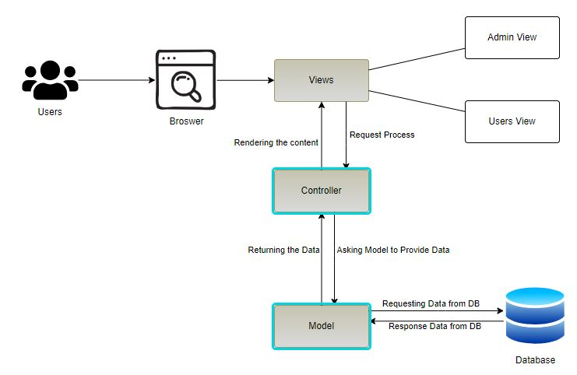

MVC Architecture Diagram

4.3 Detailed Design

4.3.1 Use Case Diagram

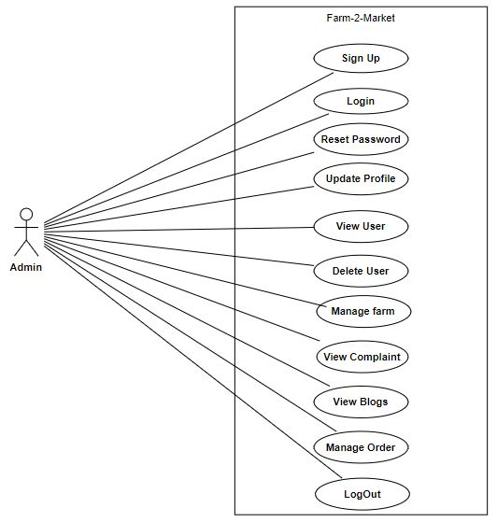

Fig 4.1: Admin Usecase Diagram

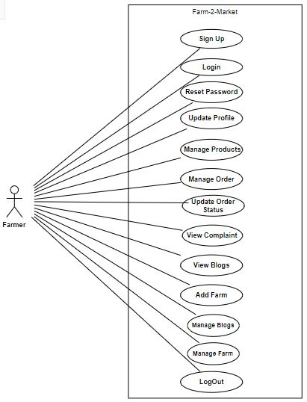

Fig 4.2: Farmer Usecase Diagram

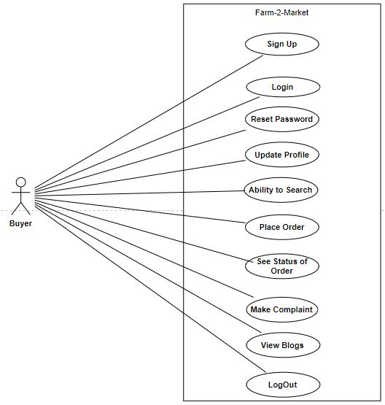

Fig 4.3: Buyer Usecase Diagram

4.3.2 Fully Address Use Case Format
Use Case-01 Admin Sign up
Use case Name | Admin Sign up
Use case ID | UC-01
Level | User Level
Primary Actor | Admin
Stakeholders And Interests | Admin will sign up for his/her account.
Precondition | Admin will provide details to fulfilment of requirements.
Post condition | Admin get himself/herself signed up with the system.
Main Success Scenario
  Action | Response
  1. Admin clicks on sign up button in admin panel.  3. Admin will provide information such as name, username, password.  5. Admin press the “Register Now” button. | 2. System displays sign up form.  4. System check the credentials entered by admin.  6. System successfully registered the admin.
Alternative Scenario | 1a. Invalid Credentials:  - Already exists, display an error message and request.  - Re-enter the credentials.  - Admin successfully registered in the system.  1b.Empty Fields:  - The system displays an error message.  - Admin will fill the empty field.
Technical Requirements | Admin will have a device, that have internet connection.

Use Case-02 Admin Login
Use case Name | Login
Use case ID | UC-02
Level | User Level
Primary Actor | Admin
Stakeholder And Interests | Admin will login to the system to manage all his/her activities
Precondition | Admin will enter his/her username and password to login
Post condition | Admin is successfully logged in
Main Success Scenario
  Action | Response
  1. Admin will click on login button.  3. Admin will enter his/her username and password for login to the system  5. Admin presses the “login” button. | 2. System will display login form.  4. System will check username and password.  6. After the validation of username and password the system will display a Admin’s home screen.

Alternative Scenario | 2a. Invalid Credentials (username and password)  - The system will display an error message  - If the credentials are invalid, display an error message.  - The admin submits the login form  - Admin successfully logged into the system
Technical Requirements | Admin will have a device, that have internet connection.

Use Case-03 Update Profile
Use case Name | Update Profile
Use case ID | UC-3
Level | User Level
Primary Actor | Admin
Stakeholder And Interests | Admin will update his information in the profile.
Precondition | Admin is logged in from his/her account and then he/she will update his profile.
Post condition | Admin successfully updated his profile.
Main Success Scenario
  Action | Response
  1. Admin clicks on “Update profile” button in popup menu.  3. Admin will see and make any changes in name, username, email and password, if necessary.  5. Admin will click “Update” button | 2. System will display the Admin’s profile page.  4. System validates the entered formats and credentials.  6. System displays confirmation message that you have successfully updated your profile.
Alternative Scenario | None
Technical Requirements | Admin will have a device, that have internet connection.

Use Case-04 Reset Password
Use case Name | Reset Password
Use case ID | UC-04
Level | User Level
Primary Actor | Admin
Stakeholder And Interests | Admin will use reset password option.
Precondition | Admin wants to login but he/she reset the password.
Post condition | Admin successfully reset his/her password.
Main Success Scenario
  Action | Response
  This use case initiates when the Admin wants to login but forgets his/her password.  1. Admin clicks on “reset Password” button in login menu.  3. Admin will enter email.  5. Admin will click on reset link and enter new password.  6. Admin will click “reset” button | 2. System will ask to enter email.  4. System validates the entered credentials and will send password reset link.  7. System displays confirmation message that your password has been successfully updated.
Alternative Scenario | 4a. Credentials not found (Wrong email/contact)  - Admin entered wrong email.  - System will display credentials not found.  - System sends the “forgot password” link.  4b. Password doesn’t match  - Admin enters different password.  - System shows password doesn’t match error  - Admin re-enters same password.  - Admin clicks on update password.  - Admin updates his password successfully.
Technical Requirements | Admin will have a device, that have internet connection.

Use Case-05 View Users
Use case Name | View users
Use case ID | UC-5
Level | User Level
Primary Actor | Admin
Stakeholder And Interests | Admin will view all the users.
Precondition | Admin is logged in from his/her account and then he/she will view all the users.
Post condition | Admin successfully viewed all the users.
Main Success Scenario
  Action | Response
  1. Admin click on “view users” option in dashboard  . | 2. System will show all the users that are registered on system.
Alternative Scenario | None
Technical Requirements | Admin will have a device, that have internet connection.

Use Case-06 Delete Users
Use case Name | Delete Users
Use case ID | UC-6
Level | User Level
Primary Actor | Admin
Stakeholder And Interests | Admin will be able to delete the user
Precondition | Admin is logged in from his/her account and then he/she will delete the user
Post condition | Admin successfully deleted a user.
Main Success Scenario
  Action | Response
  This use case initiates when the admin wants delete user account.  1. Admin finds an account to delete.  3. Admin clicks on delete account. | 2. System will display the specific user account.  4. System displays confirmation message that account deleted successfully.
Alternative Scenario | 6a. Invalid entry:  - The system displays an error message  - Admin will re-enter the search user data for the user account to find and delete.  - The admin click the delete button  - Admin successfully deleted a user account.
Technical Requirements | Admin will have a device, that have internet connection.

Use Case-07 View Complaints
Use case Name | View Complaints
Use case ID | UC-07
Level | User Level
Primary Actor | Admin
Stakeholder And Interests | Admin will be able to view all the complaints.
Precondition | Admin is logged in from his/her account and then he/she will view reports.
Post condition | Admin successfully viewed complaints
Main Success Scenario
  Action | Response
  This use case initiates when the admin wants to view complaints.  1. Admin clicks on “view complaints” in admin menu.  3. Admin successfully viewed all the complaints. | 2. System will display the complaints page in response.
Alternative Scenario | None
Technical Requirements | Admin will have a device, that have internet connection.

Use Case-08 View Blogs
Use case Name | View Blogs
Use case ID | UC-08
Level | User Level
Primary Actor | Admin
Stakeholder And Interests | Admin will be able to view all the blogs.
Precondition | Admin is logged in from his/her account and then he/she will view blogs.
Post condition | Admin successfully viewed blogs.
Main Success Scenario
  Action | Response
  This use case initiates when the admin wants to view blogs.  1. Admin clicks on “view blogs” in admin menu.  3. Admin successfully viewed all the blogs. | 2. System will display the blogs page in response.
Alternative Scenario | None
Technical Requirements | Admin will have a device, that have internet connection.

Use Case-09 Manage Farm
Use case Name | Manage Farm
Use case ID | UC-09
Level | User Level
Primary Actor | Admin
Stakeholder And Interests | Admin will manage farm
Precondition | Admin is logged in from his/her account and then he/she will be able to manage farm.
Post condition | Admin successfully managed the farms.
Main Success Scenario
  Action | Response
  This use case initiates when the admin needs to managed the farms.  1. Admin clicks on manage farm button in the dashboard.  3. Admin will select that what will do the farm update/delete.  5. Admin will enter credentials according to form. | 2. System will display the portal of manage farm.  4. System show forms according to selected by the admin.  6. System show message that “Farm Managed Successfully”.
Alternative Scenario | - Admin will not manage farms.
Technical Requirements | Admin must have a device capable to run browser and internet connection

Use Case-10 Manage Order
Use case Name | Manage Order
Use case ID | UC-10
Level | User Level
Primary Actor | Admin
Stakeholder And Interests | Admin will manage the sale of order that the farmer and buyer will be placed.
Precondition | Admin want to managed the orders that placed by farmer and buyer.
Post condition | Admin can successfully managed the orders.
Main Success Scenario
  Action | Response
  - Admin click on manage order button in the admin portal.  - Admin select the order to managed.  - Admin select what to update cancel/approved. | - System display a page where all orders is shown.
Alternative Scenario | None
Technical Requirements | Admin will have a device, that have internet connection.

Use Case-11 logout
Use case Name | Logout
Use case ID | UC-11
Level | User Level
Primary Actor | Admin
Stakeholder And Interests | Admin will logout from his/her account
Precondition | Admin is logged in from his/her account and then he/she will logout from his/her account.
Post condition | Admin successfully logged out from his/her account.
Main Success Scenario
  Action | Response
  This use case initiates when the admin wants to logout from his/her account.  1. Admin clicks on “logout” button.  3. Admin clicks on “logout” button in pop up. | 2. System will display the logout confirmation pop up.  4. System displays confirmation message that you have been successfully logged out.
Alternative Scenario | - Admin clicks on cancel button.  - System cancels the logout process.
Technical Requirements | Admin will have a device, that have internet connection.

Use Case-12 Farmer Sign up
Use case Name | Farmer Sign up
Use case ID | UC-12
Level | User Level
Primary Actor | Farmers
Stakeholders And Interests | Farmers will sign up his/her account to further continue the use of system.
Precondition | Farmers will provide all the details that is necessary for the signup.
Post condition | Farmers get himself/herself signed up with the system.
Main Success Scenario
  Action | Response
  This use case initiates by the  Farmers when he/she wants to sign on system.  1. Farmer clicks on sign up button in app.  3. Farmer enters mandatory information such as name, contact number, email, and password.  5. Farmer press the “create account” button. | 2. System displays sign up form.  4. System checks the formats and credentials entered by customer  6. System successfully signed up the user.
Alternative Scenario | Invalid Credentials:  - The system displays an error message.  - Re-enter the details.  - Click on create account button.  - Farmer successfully signed up in the system.  Empty Fields:  - The system displays an error message.  - Farmer will fill the empty field..
Technical Requirements | Farmers will have a device, that have internet connection.

Use Case-13 Farmer Login
Use case Name | Login
Use case ID | UC-13
Level | User Level
Primary Actor | Farmers
Stakeholder And Interests | Farmers will login to manage crops and other his/her activities.
Precondition | Farmers will enter email/content no and password to login in the system.
Post condition | User will be logged in successfully.
Main Success Scenario
  Action | Response
  This use case is initiated by the user when he/she wants to login  1. Farmers will click on login button.  3. Farmer will enter email/content no and password in there places.  4. Farmer presses the “login” button. | 2. System will display login form where farmer enter his/her information.  5. System will check the credentials entered by the farmer.  6. System will validate the credentials and will successfully login the farmer.
Alternative Scenario | Invalid Credentials (username and password)  - The system will display an error message  - If the credentials are invalid, display an error message.  - The farmer submits the login form  - Farmer successfully logged into the system
Technical Requirements | Farmers will have a device, that have internet connection.

Use Case-14 Update Profile
Use case Name | Update Profile
Use case ID | UC-14
Level | User Level
Primary Actor | Farmer
Stakeholder And Interests | Farmer will update his information in the profile.
Precondition | Farmer is logged in from his/her account and then he/she will update his profile.
Post condition | Farmer successfully updated his profile.
Main Success Scenario
  Action | Response
  1. Farmer clicks on “Update profile” button in popup menu.  3. Farmer will see and make any changes in name, username, email and password, if necessary.  5. Farmer will click “Update” button | 2. System will display the Farmer’s profile page.  4. System validates the entered formats and credentials.  6. System displays confirmation message that you have successfully updated your profile.
Alternative Scenario | None
Technical Requirements | Farmer will have a device, that have internet connection.

Use Case-15 Reset Password
Use case Name | Reset Password
Use case ID | UC-15
Level | User Level
Primary Actor | Farmer
Stakeholder And Interests | Farmer will use forget option if he/she forget the password.
Precondition | Farmers want to login the system but forget the password.
Post condition | Farmer successfully changed the password.
Main Success Scenario
  Action | Response
  1. Farmer clicks on “Forget Password” button in the login page.  3. Farmer will enter his/her email/contact number for varification.  5. Farmer will enter the OTP, then Enter the new password twice. | 2. System will display the forget password page.  4. System validates the entered formats and credentials and then send OTP.  6. System the format of the password and then display the massage you have been successfully change the password.
Alternative Scenario | Farmer will Enter the wrong credentials system will display an Error massage.  Farmer will Enter the wrong password format and system will display an Error massage.
Technical Requirements | Farmer will have a device, that have internet connection.

Use Case-16 Manage Product
Use case Name | Manage Product
Use case ID | UC-16
Level | User Level
Primary Actor | Farmer
Stakeholder And Interests | Farmer will use manage product option from which he/she will managed all their products.
Precondition | Farmers want to managed the products.
Post condition | Farmers managed their crops as they have to need it.
Main Success Scenario
  Action | Response
  1. Farmer clicks on manage product option in the farmer’s portal.  3. Farmer will select the product that will need to manage.  5. Farmer will enter the new details that he/she will need to changed.  6. And then press submit button. | 2. System will display the page where farmer add info about products.  4. System open the new page where all details of selected products is placed.  7. System display the massage that Changes successfully updated.
Alternative Scenario | None
Technical Requirements | Farmer will have a device, that have internet connection.

Use Case-17 Manage Order
Use case Name | Manage Order
Use case ID | UC-17
Level | User Level
Primary Actor | Farmer
Stakeholder And Interests | Farmer will manage the sale of order that the buyer will be placed.
Precondition | Farmers want to managed the orders that placed by buyer.
Post condition | Farmers can successfully managed the orders.
Main Success Scenario
  Action | Response
  - Farmers click on manage order button in the farmer portal.  - Farmer select the order to managed.  - Farmer select what to update cancel/approved. | - System display a page where all orders is shown.
Alternative Scenario | None
Technical Requirements | Farmer will have a device, that have internet connection.

Use Case-18 Update Order Status
Use case Name | Update Order Status
Use case ID | UC-18
Level | User Level
Primary Actor | Farmer
Stakeholder And Interests | Farmer will easily update the status of order.
Precondition | Farmers want to update the status of order.
Post condition | Farmers can successfully update status of orders.
Main Success Scenario
  Action | Response
  - Farmers click on update status order button in the orders page.  - Farmer select the order to update status.  - Farmer select the status of order. | - System display the status suggestions  - System successfully updated the status.
Alternative Scenario | None
Technical Requirements | Farmer will have a device, that have internet connection.

Use Case-19 View Complaints
Use case Name | View Complaints
Use case ID | UC-19
Level | User Level
Primary Actor | Farmer
Stakeholder And Interests | Farmer will be able to view all the complaints.
Precondition | Farmer is logged in from his/her account and then he/she will view reports.
Post condition | Farmer successfully viewed complaints
Main Success Scenario
  Action | Response
  This use case initiates when the farmer wants to view complaints.  1. Farmer clicks on “view complaints” in admin menu.  3. Farmer successfully viewed all the complaints. | 2. System will display the complaints page in response.
Alternative Scenario | None
Technical Requirements | Farmer will have a device, that have internet connection.

Use Case-20 View Blogs
Use case Name | View Blogs
Use case ID | UC-20
Level | User Level
Primary Actor | Farmer
Stakeholder And Interests | Farmer will be able to view all the blogs.
Precondition | Farmer is logged in from his/her account and then he/she will view blogs.
Post condition | Farmer successfully viewed blogs.
Main Success Scenario
  Action | Response
  This use case initiates when the farmer wants to view blogs.  1. Farmer clicks on “view blogs” in farmer menu.  3. Farmer successfully viewed all the blogs. | 2. System will display the blogs page in response.
Alternative Scenario | None
Technical Requirements | Farmer will have a device, that have internet connection.

Use Case-21 Add Farm
Use case Name | Add Farm
Use case ID | UC-21
Level | User Level
Primary Actor | Farmer
Stakeholder And Interests | Farmer will add farm according to buyers need.
Precondition | Farmer is logged in from his/her account and then he/she will add farm.
Post condition | Farmer successfully added farm.
Main Success Scenario
  Action | Response
  This use case initiates when the farmer wants to upload farm.  1. Farmer clicks on “Add Farms” button in farmer menu.  3. Farmer will input the credentials related to farm.  5. Farmer will click on “add” button. | 2. System will display the add farm page to farmer  4. System will verify the credentials  6. System will successfully add the farm.
Alternative Scenario | 12a.Empty Fields  - The system displays an error message  - Farmer will fill the empty field  Farmer successfully added farm into the system
Technical Requirements | Farm must have a device capable to run browser and internet connection

Use Case-22 Manage Blogs
Use case Name | Manage Blogs
Use case ID | UC-22
Level | User Level
Primary Actor | Farmer
Stakeholder And Interests | Farmer will manage blogs
Precondition | farmer is logged in from his/her account and then he/she will be able to manage blog.
Post condition | farmer successfully managed the blogs.
Main Success Scenario
  Action | Response
  This use case initiates when the farmer needs to managed the blogs.  1. Farmer clicks on manage blog button in the dashboard.  3. Farmer will select that what will do the farm update/delete.  5. Farmer will enter credentials according to form. | 2. System will display the portal of manage blog.  4. System show forms according to selected by the farmer.  6. System show message that “Blog Managed Successfully”.
Alternative Scenario | - Farmer will not manage farms.
Technical Requirements | Farmer must have a device capable to run browser and internet connection

Use Case-23 Manage Farm
Use case Name | Manage Farm
Use case ID | UC-23
Level | User Level
Primary Actor | Farmer
Stakeholder And Interests | Farmer will manage farm
Precondition | Farmer is logged in from his/her account and then he/she will be able to manage farm.
Post condition | Farmer successfully managed the farms.
Main Success Scenario
  Action | Response
  This use case initiates when the farmer needs to managed the farms.  1. Farmer clicks on manage farm button in the dashboard.  3. Farmer will select that what will do the farm update/delete.  5. Farmer will enter credentials according to form. | 2. System will display the portal of manage farm.  4. System show forms according to selected by the farmer.  6. System show message that “Farm Managed Successfully”.
Alternative Scenario | - Farmer will not manage farms.
Technical Requirements | Farmer must have a device capable to run browser and internet connection

Use Case-24 logout
Use case Name | Logout
Use case ID | UC-24
Level | User Level
Primary Actor | Farmer
Stakeholder And Interests | Farmers will logout from his/her account
Precondition | Farmers is logged in from his/her account and then he/she will logout from his/her account.
Post condition | Farmers successfully logged out from his/her account.
Main Success Scenario
  Action | Response
  This use case initiates when the farmer wants to logout from his/her account.  1. Farmers clicks on “logout” button.  3. Farmers clicks on “logout” button in pop up. | 2. System will display the logout confirmation pop up.  4. System displays confirmation message that you have been successfully logged out.
Alternative Scenario | - Farmer clicks on cancel button.  - System cancels the logout process.
Technical Requirements | Farmers will have a device, that have internet connection.

Use Case-25 Buyer Sign up
Use case Name | Buyer Sign up
Use case ID | UC-25
Level | User Level
Primary Actor | Buyer
Stakeholders And Interests | Buyers will sign up his/her account to further continue the use of system.
Precondition | Buyers will provide all the details that is necessary for the signup.
Post condition | Buyers get himself/herself signed up with the system.
Main Success Scenario
  Action | Response
  This use case initiates by the  Buyers when he/she wants to sign on system.  1. Buyer clicks on sign up button in app.  3. Buyer enters mandatory information such as name, contact number, email, and password.  5. Buyer press the “create account” button. | 2. System displays sign up form.  4. System checks the formats and credentials entered by customer  6. System successfully signed up the user.
Alternative Scenario | Invalid Credentials:  - The system displays an error message.  - Re-enter the details.  - Click on create account button.  - Buyer successfully signed up in the system.  Empty Fields:  - The system displays an error message.  - Buyer will fill the empty field..
Technical Requirements | Buyers will have a device, that have internet connection.

Use Case-26 Buyer Login
Use case Name | Login
Use case ID | UC-26
Level | User Level
Primary Actor | Buyers
Stakeholder And Interests | Buyers will login to manage crops and other his/her activities.
Precondition | Buyers will enter email/content no and password to login in the system.
Post condition | Buyer will be logged in successfully.
Main Success Scenario
  Action | Response
  This use case is initiated by the buyer when he/she wants to login  1. Buyers will click on login button.  3. Buyer will enter email/content no and password in their places.  4. Buyer presses the “login” button. | 2. System will display login form where buyer enter his/her information.  5. System will check the credentials entered by the buyer.  6. System will validate the credentials and will successfully login the buyer.
Alternative Scenario | Invalid Credentials (username and password)  - The system will display an error message  - If the credentials are invalid, display an error message.  - The buyer submits the login form  - Buyer successfully logged into the system
Technical Requirements | Buyers will have a device, that have internet connection.

Use Case-27 Update Profile
Use case Name | Update Profile
Use case ID | UC-27
Level | User Level
Primary Actor | Buyer
Stakeholder And Interests | Buyer will update his information in the profile.
Precondition | Buyer is logged in from his/her account and then he/she will update his profile.
Post condition | Buyer successfully updated his profile.
Main Success Scenario
  Action | Response
  1. Buyer clicks on “Update profile” button in popup menu.  3. Buyers will see and make any changes in name, username, email and password, if necessary.  5. Buyer will click “Update” button | 2. System will display the Buyer’s profile page.  4. System validates the entered formats and credentials.  6. System displays confirmation message that you have successfully updated your profile.
Alternative Scenario | None
Technical Requirements | Buyer will have a device, that have internet connection.

Use Case-28 Reset Password
Use case Name | Reset Password
Use case ID | UC-28
Level | User Level
Primary Actor | Buyer
Stakeholder And Interests | Buyer will use reset option if he/she forget the password.
Precondition | Buyers want to login the system but reset the password.
Post condition | Buyer successfully changed the password.
Main Success Scenario
  Action | Response
  1. Buyer clicks on “Forget Password” button in the login page.  3. Buyer will enter his/her email/contact number for verification.  5. Buyer will enter the OTP, then Enter the new password twice. | 2. System will display the forget password page.  4. System validates the entered formats and credentials and then send OTP.  6. System the format of the password and then display the massage you have been successfully change the password.
Alternative Scenario | - Buyer will Enter the wrong credentials system will display an Error massage.  - Buyer will Enter the wrong password format and system will display an Error massage.
Technical Requirements | Buyer will have a device, that have internet connection.

Use Case-29 Ability to Search
Use case Name | Ability to Search
Use case ID | UC-29
Level | User Level
Primary Actor | Buyer
Stakeholder And Interests | Buyer want search and find specific products of interest within the software.
Precondition | Buyers want to search anything that he/she will need to use.
Post condition | Buyer easily find the thing that he/she want by use search option.
Main Success Scenario
  Action | Response
  1. Buyer clicks on the search functionality in the top of the buyer’s interface.  3. Buyer will enter keywords or product names in the search bar.  5. Buyer will select a specific product for more information or to proceed with the purchase. | 2. System will automatically open the keyboard.  4. System displays the search results based on the entered keywords.
Alternative Scenario | - If the buyer is unsure about specific keywords or product names.  - If no search results are found, display a message indicating no matching products and suggest alternative search terms or products.
Technical Requirements | Buyer will have a device, that have internet connection.

Use Case-30 Place Order
Use case Name | Place Order
Use case ID | UC-30
Level | User Level
Primary Actor | Buyer
Stakeholder And Interests | Buyer want to place an order for selected products within the farm-2-market software.
Precondition | Buyers want to place an order for the product he/she want to use.
Post condition | Buyer successfully placed his/her order.
Main Success Scenario
  Action | Response
  1. Buyer browse or search for products of interest within the software.  3. Buyer will select a specific product.  5. Buyer open the cart and select the quantity of the product that he/she selected and then click now “Buy Now” button.  7. Buyer select payment option.  9. Buyers placed his/her information for delivery.  10. Buyer click on the “Placed order” button. | 2. System will show the products related to buyer search.  4. System add the product that buyer select in the cart.  6. System will show payment method.  8. System open the form where buyer placed information such as name, contact number and address for delivery.  11. System will show a massage that “Order placed Successfully”.
Alternative Scenario | 3a. If the selected products exceed the available stock quantity, then show out of stock.  8a. If the buyer has multiple shipping addresses, provide an option to select from saved addresses or enter a new one.
Technical Requirements | Buyer will have a device, that have internet connection.

Use Case-31 See Status of Order
Use case Name | See Status of Order
Use case ID | UC-31
Level | User Level
Primary Actor | Buyer
Stakeholder And Interests | Check and view the status of an order placed within the Farm-2-Market software.
Precondition | Buyers want to see the status of the placed ordered.
Post condition | Buyers can easily see the status of the placed order.
Main Success Scenario
  Action | Response
  1. Buyer click on the order history from the dashboard of buyers.  3. Buyer will select the specific order for which the status needs to be checked.  5. Buyer see all the details of the placed order that where it is and when it will be delivered. | 2. System will show the page where all the order for last few months is placed.  4. System show the order details.
Alternative Scenario | 3a. If the order history is extensive, provide search or filtering options to locate the specific order quickly (e.g., by order number, date range).
Technical Requirements | Buyer will have a device, that have internet connection.

Use Case-32 Make Complaint
Use case Name | Make Complaint
Use case ID | UC-32
Level | User Level
Primary Actor | Buyer
Stakeholder And Interests | Buyer will be able to make the complaint related the products.
Precondition | Buyer is logged in from his/her account and then he/she will make complaint.
Post condition | Buyer successfully make the complaint.
Main Success Scenario
  Action | Response
  This use case initiates when the buyer wants to view blogs.  1. Buyer clicks on “make complaint” in buyer menu.  3. Buyer successfully make the complaint. | 2. System will display the page where buyer write complaint.
Alternative Scenario | None
Technical Requirements | Buyer will have a device, that have internet connection.

Use Case-33 View Blogs
Use case Name | View Blogs
Use case ID | UC-08
Level | User Level
Primary Actor | Buyer
Stakeholder And Interests | Buyer will be able to view all the blogs.
Precondition | Buyer is logged in from his/her account and then he/she will view blogs.
Post condition | Buyer successfully viewed blogs.
Main Success Scenario
  Action | Response
  This use case initiates when the buyer wants to view blogs.  1. Buyer clicks on “view blogs” in buyer menu.  3. Buyer successfully viewed all the blogs. | 2. System will display the blogs page in response.
Alternative Scenario | None
Technical Requirements | Buyer will have a device, that have internet connection.

Use Case-34 logout
Use case Name | Logout
Use case ID | UC-26
Level | User Level
Primary Actor | Buyer
Stakeholder And Interests | Buyer will logout from his/her account
Precondition | Buyer is logged in from his/her account and then he/she will logout from his/her account.
Post condition | Buyers successfully logged out from his/her account.
Main Success Scenario
  Action | Response
  This use case initiates when the buyer wants to logout from his/her account.  1. Buyer clicks on “logout” button.  3. Buyer clicks on “logout” button in pop up. | 2. System will display the logout confirmation pop up.  4. System displays confirmation message that you have been successfully logged out.
Alternative Scenario | - Buyer clicks on cancel button.  - System cancels the logout process.
Technical Requirements | Buyer will have a device, that have internet connection.

4.3.3 Sequence Diagram

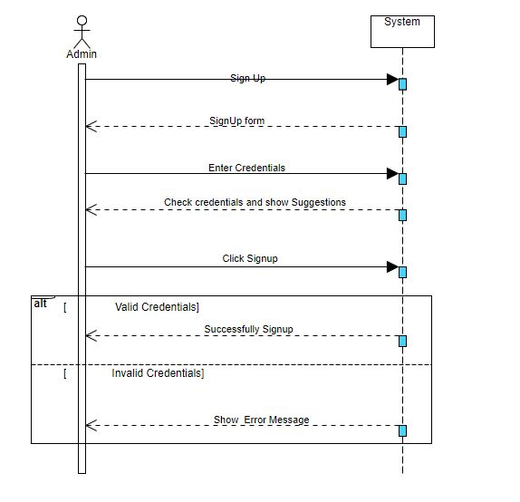

Fig 4.4 Admin Signup Sequence Diagram

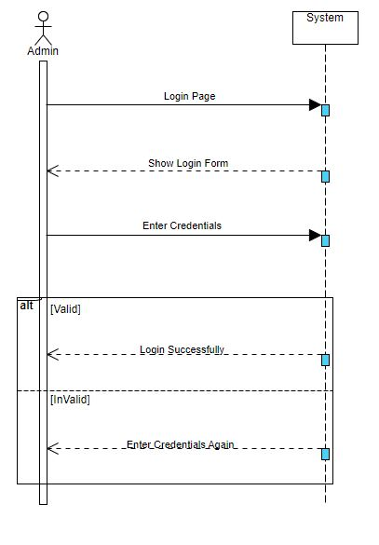

Fig 4.5 Admin LogIn Sequence Diagram

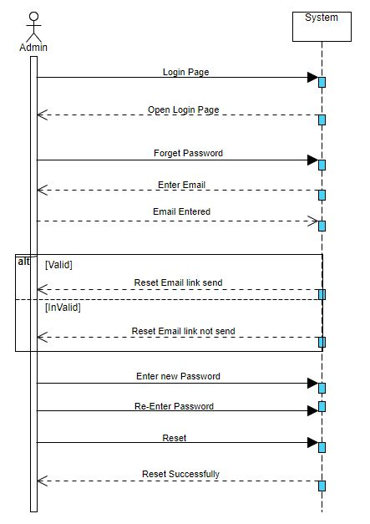

Fig 4.6 Admin Reset Password Sequence Diagram

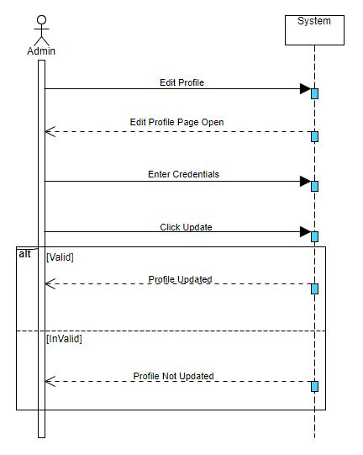

Fig 4.7 Admin Update Profile Sequence Diagram

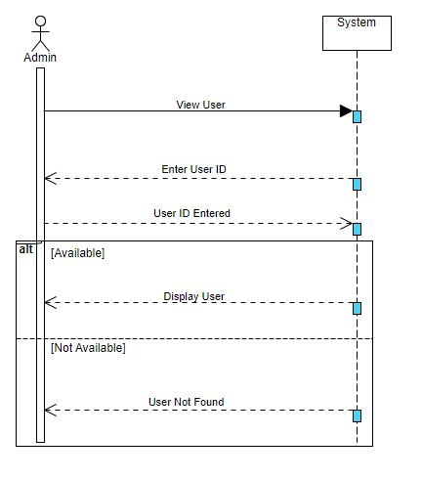

Fig 4.8 Admin View User Sequence Diagram

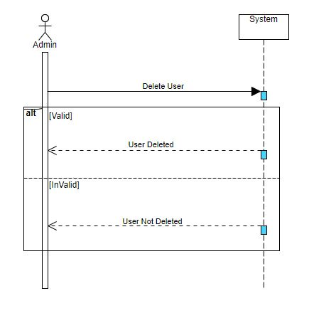

Fig 4.9 Admin Delete User Sequence Diagram

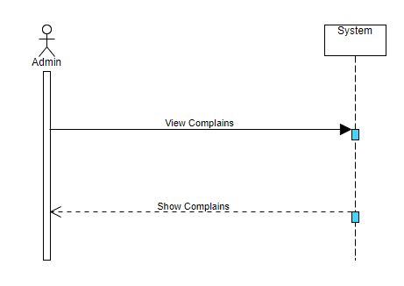

Fig 4.10 Admin View Complain Sequence Diagram
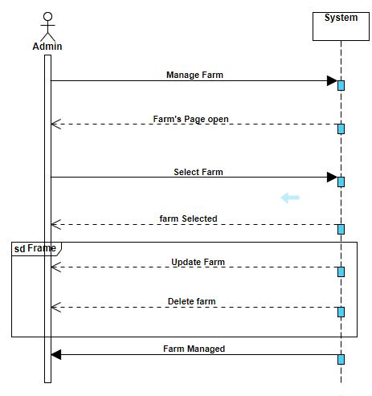

Fig 4.11 Admin manage farm Sequence Diagram

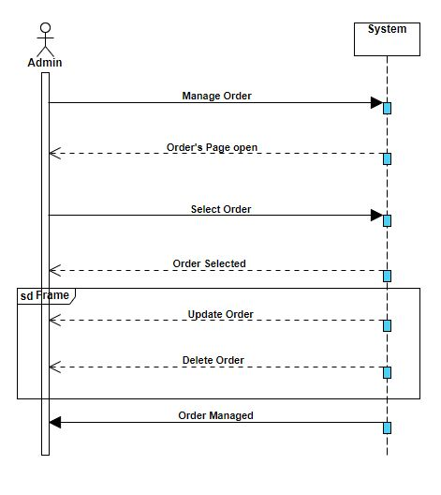

Fig 4.12 Admin manage order Sequence Diagram
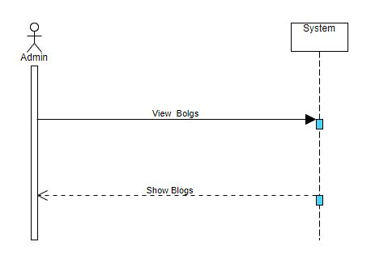
Fig 4.13 Admin View Blogs Sequence Diagram
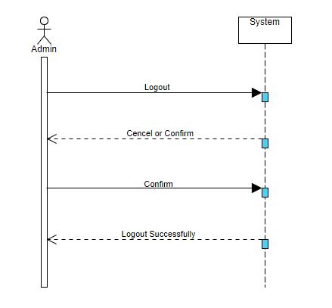

Fig 4.14 Admin Logout Sequence Diagram
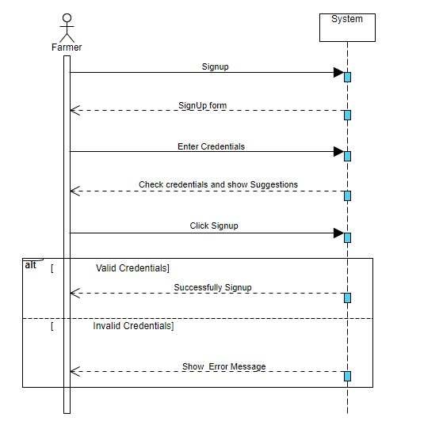

Fig 4.15 Farmer Signup Sequence Diagram

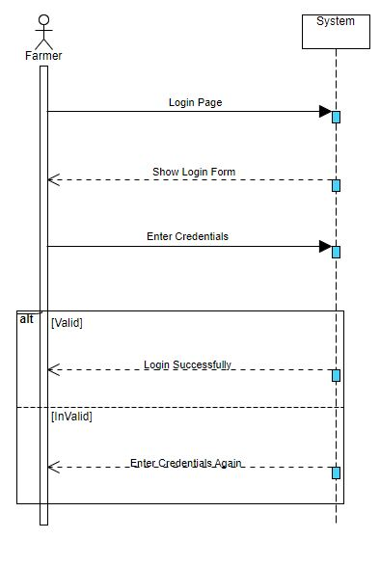

Fig 4.16 Farmer Login Sequence Diagram

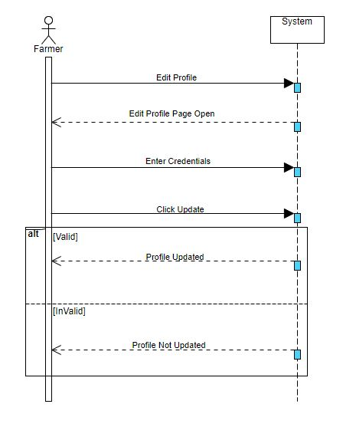

Fig 4.17 Farmer Update Profile Sequence Diagram

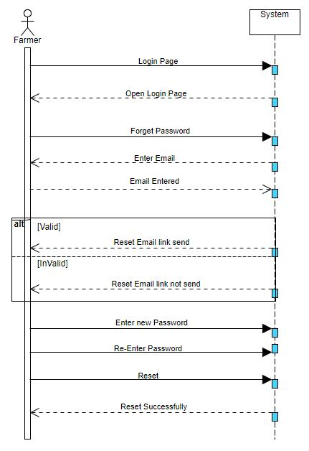

Fig 4.18 Farmer Reset Password Sequence Diagram

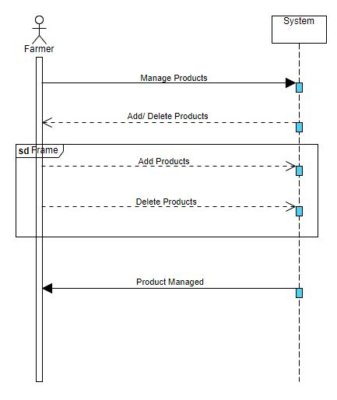

Fig 4.19 Farmer Manage Product Sequence Diagram

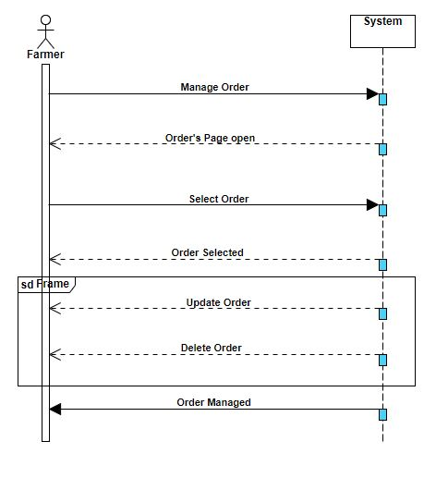

Fig 4.20 Farmer Manage Order Sequence Diagram
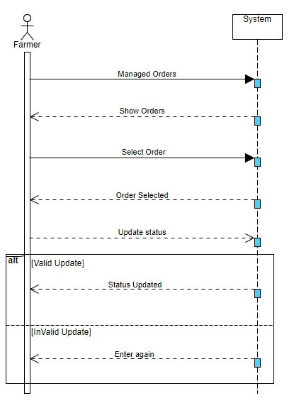

Fig 4.21 Farmer Update Order Status Sequence Diagram
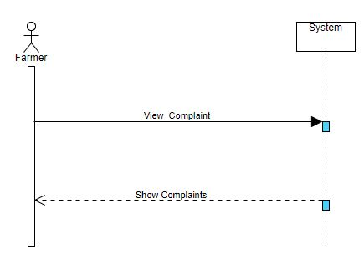
Fig 4.22 Farmer View Complaint Sequence Diagram

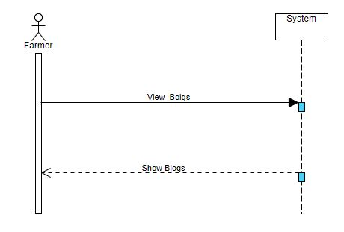
Fig 4.23 Farmer View Blogs Sequence Diagram

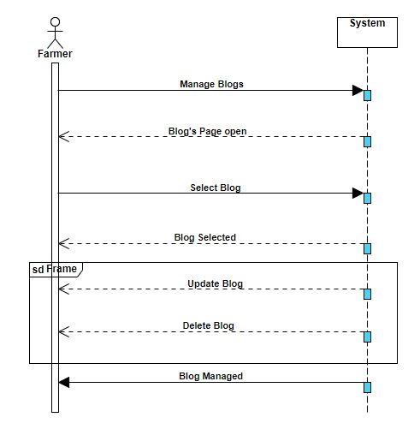

Fig 4.24 Farmer Manage Blog Sequence Diagram
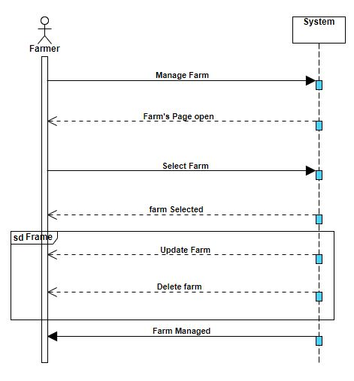

Fig 4.25 Farmer Manage farm Sequence Diagram

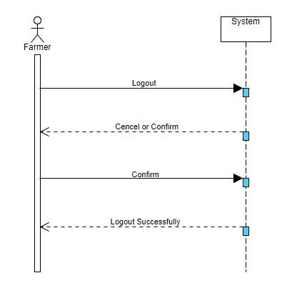

Fig 4.26 Farmer Logout Sequence Diagram

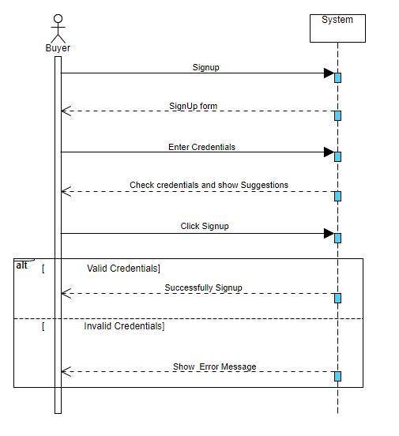

Fig 4.27 Buyer Signup Sequence Diagram

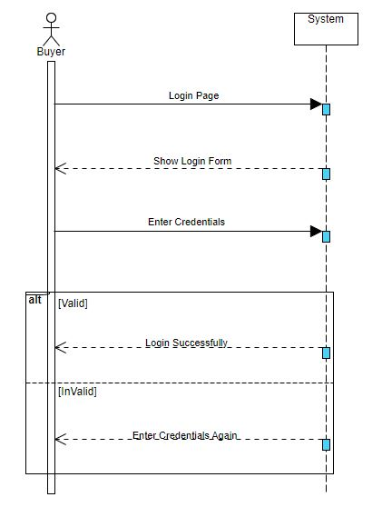

Fig 4.28 Buyer LogIn Sequence Diagram

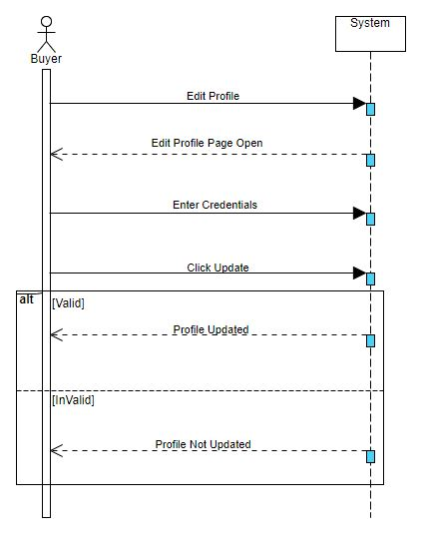

Fig 4.29 Buyer Update Profile Sequence Diagram
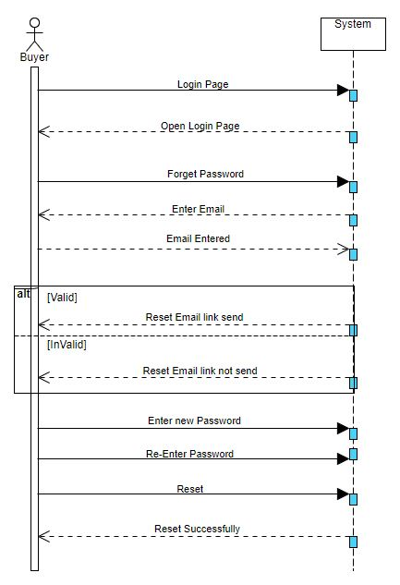

Fig 4.30 Buyer Reset Password Sequence Diagram

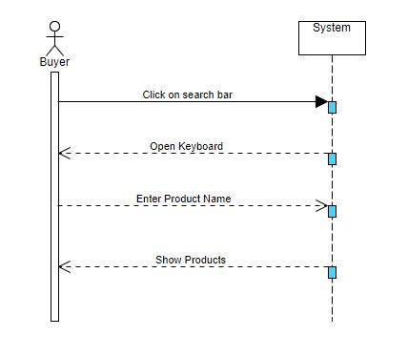

Fig 4.31 Buyer Ability to Search Sequence Diagram

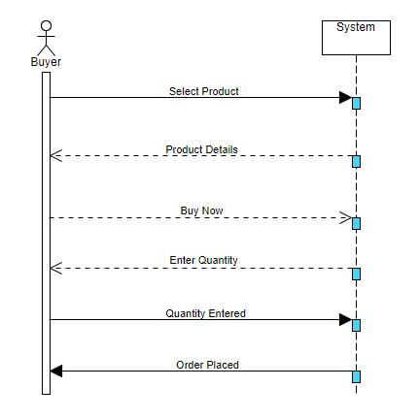

Fig 4.32 Buyer Placed Order Sequence Diagram

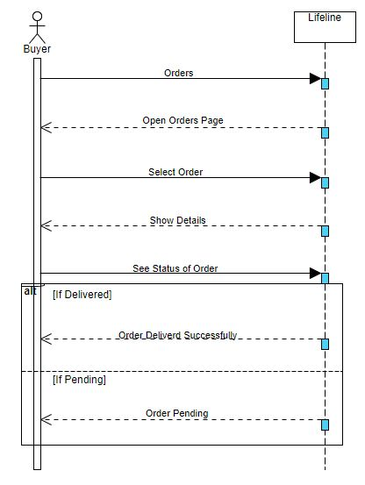

Fig 4.33 Buyer See Order Status Sequence Diagram
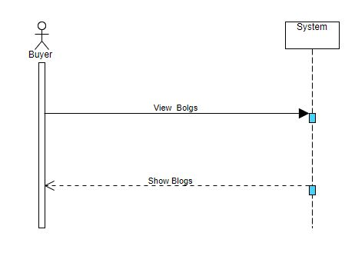
Fig 4.34 Buyer View Blogs Sequence Diagram

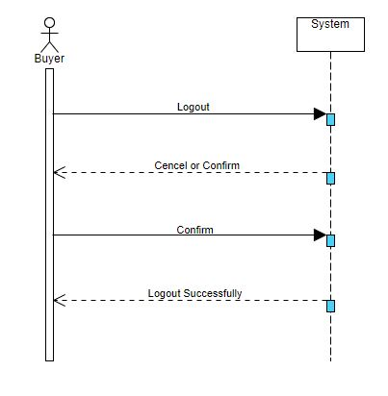

Fig 4.35 Buyer Logout Sequence Diagram

4.3.4 Activity Diagrams
4.3.4.1 Admin’s Activity Diagrams:
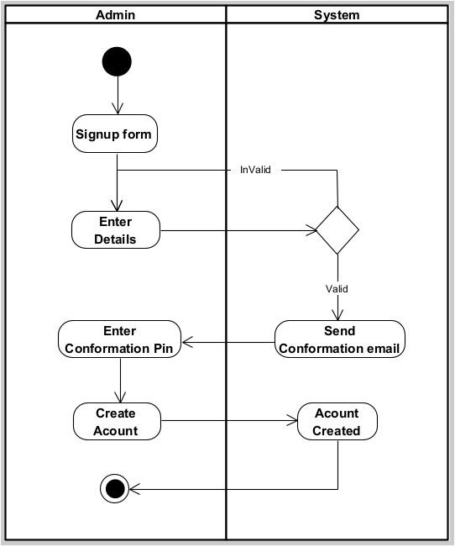

Fig 4.36 Admin Signup Activity Diagram

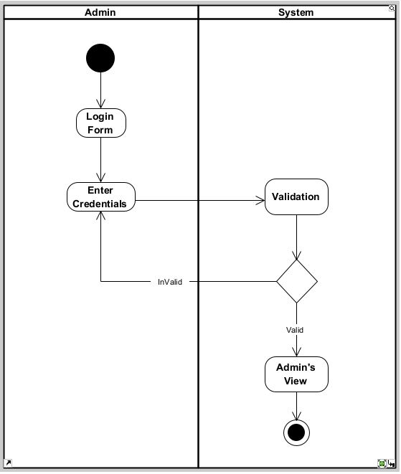

Fig 4.37 Admin Login Activity Diagram
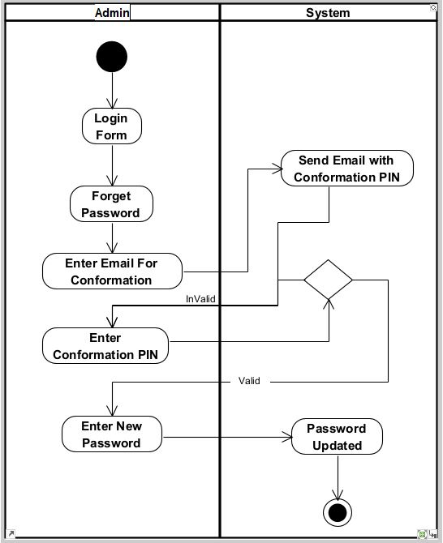

Fig 4.38 Admin Reset Password Activity Diagram
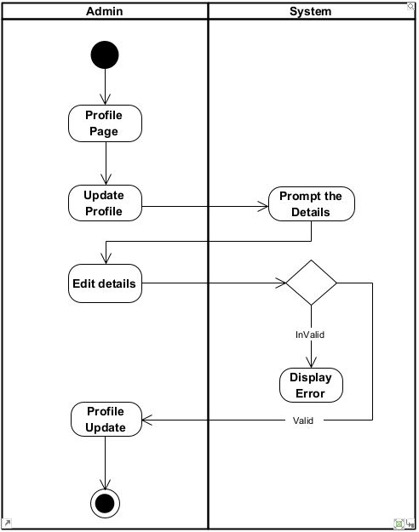

Fig 4.39 Admin Update Profile Activity Diagram
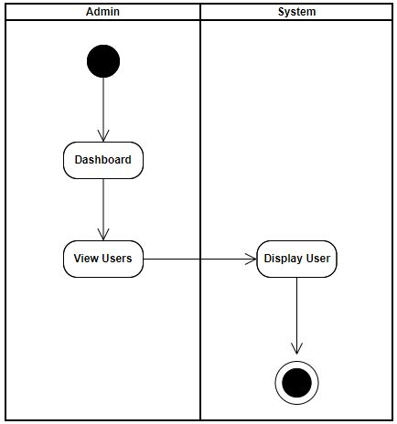

Fig 4.40 Admin View User Activity Diagram
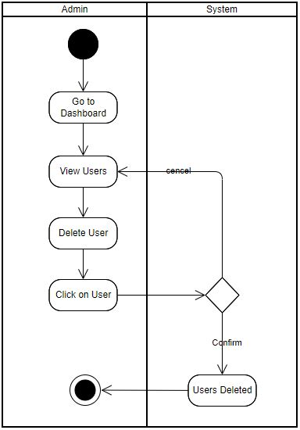

Fig 4.41 Admin Delete User Activity Diagram

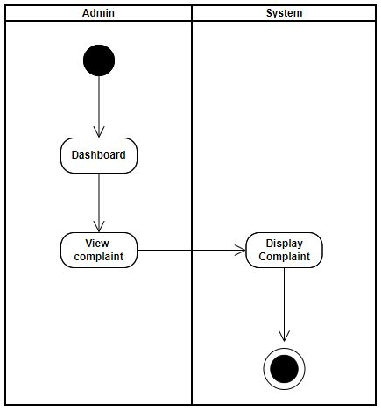

Fig 4.42 Admin View Complaint Activity Diagram
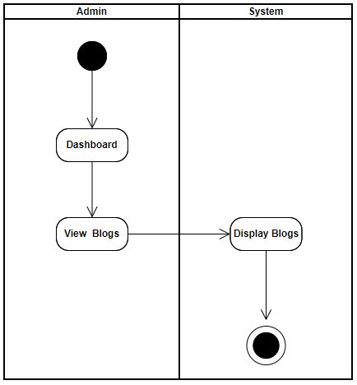

Fig 4.43 Admin View Blogs Activity Diagram
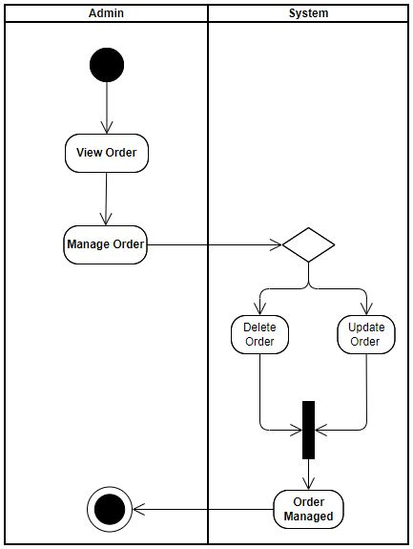

Fig 4.44 Manage Order Activity Diagram
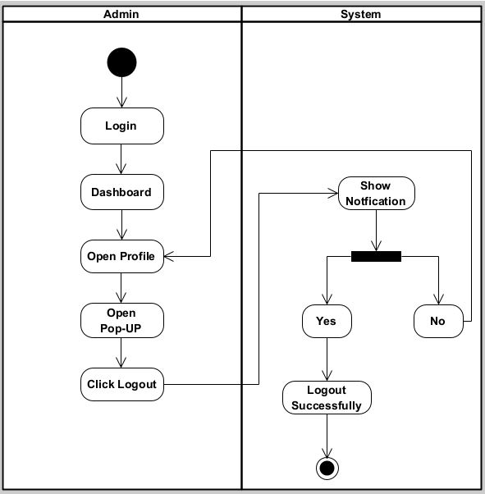

Fig 4.45 Admin Logout Activity Diagram

4.3.4.2 Farmer’s Activity Diagrams
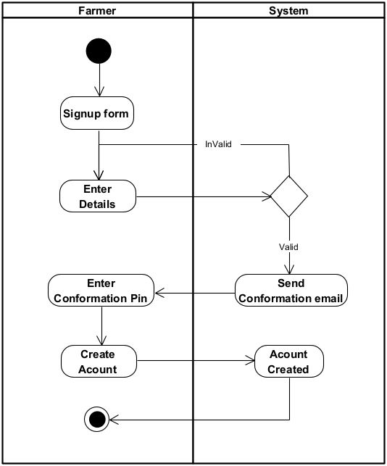

Fig 4.46 Farmer Signup Activity Diagram
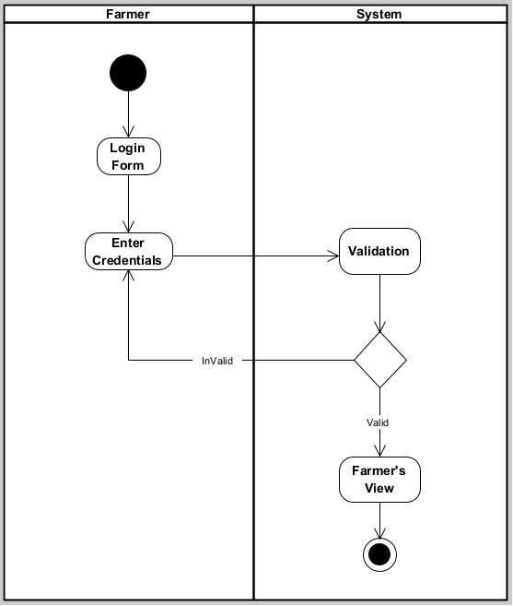

Fig 4.47 Farmer Login Activity Diagram
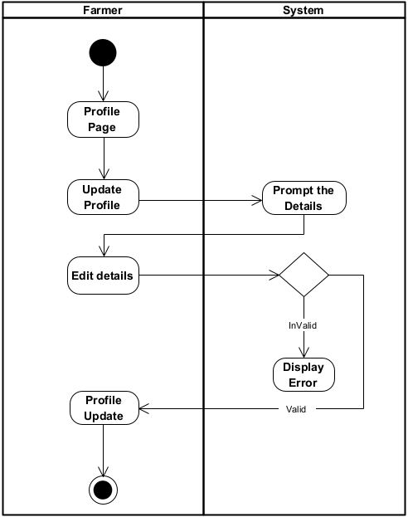

Fig 4.48 Farmer Update Profile Activity Diagram
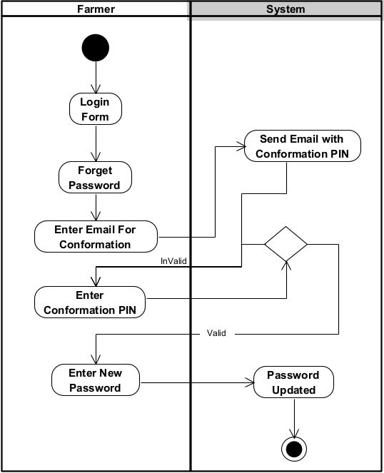

Fig 4.49 Farmer Reset Password Activity Diagram
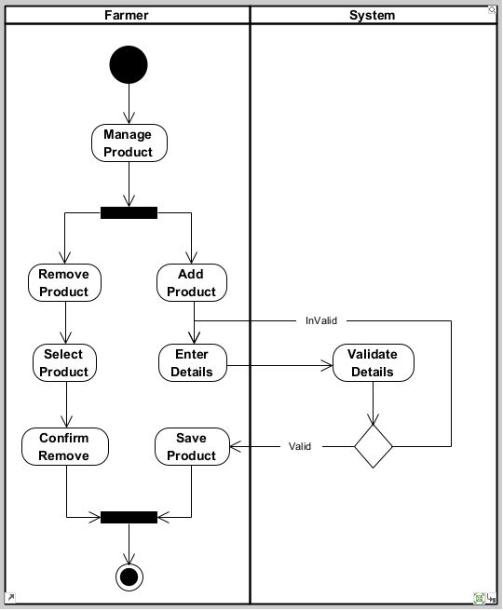

Fig 4.50 Farmer Manage Product Activity Diagram
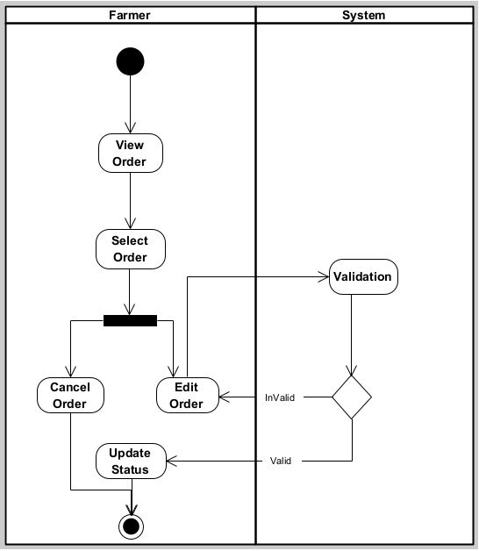

Fig 4.51 Farmer Manage Order Activity Diagram
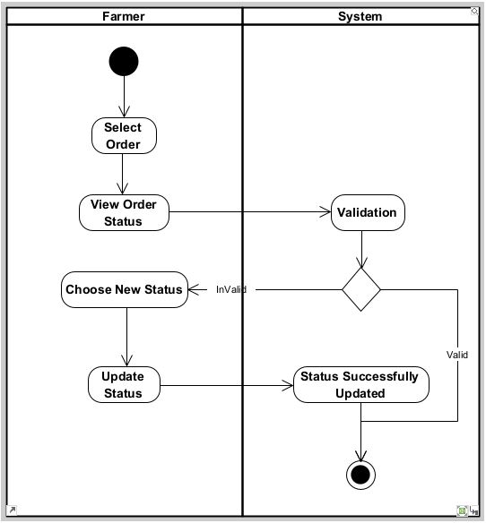

Fig 4.52 Farmer Update Order Status Activity Diagram
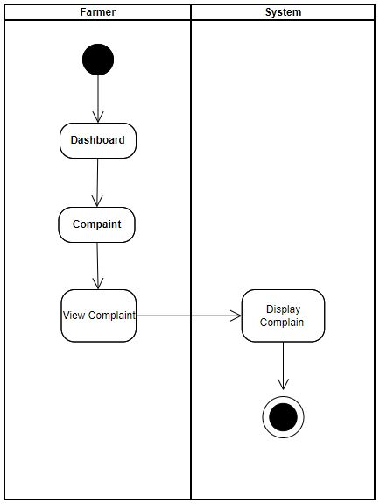

Fig 4.53 Farmer View Complaint Activity Diagram

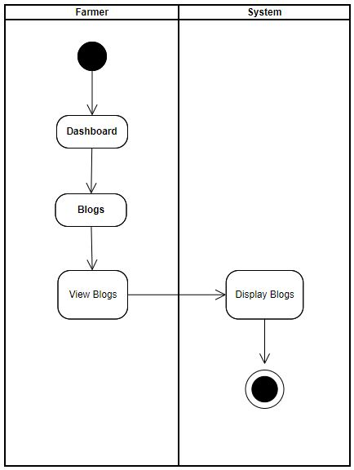

Fig 4.54 Farmer View Blogs Activity Diagram

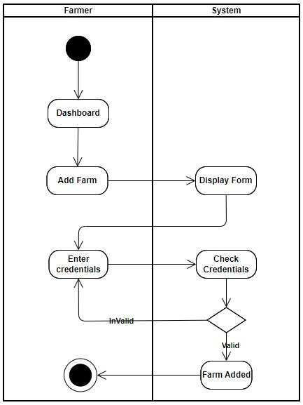

Fig 4.55 Farmer Add Farm Activity Diagram
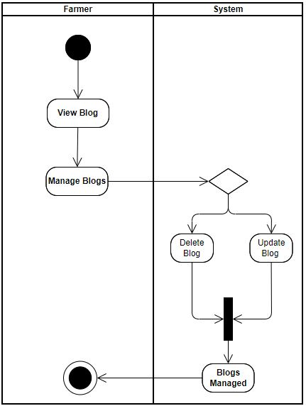

Fig 4.56 Farmer Manage Blog Activity Diagram
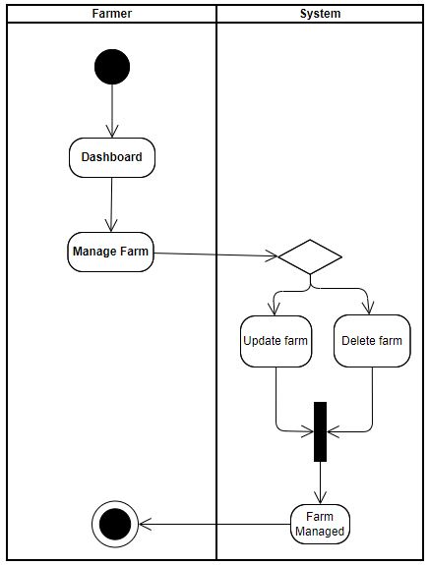

Fig 4.57 Farmer Manage farm Activity Diagram

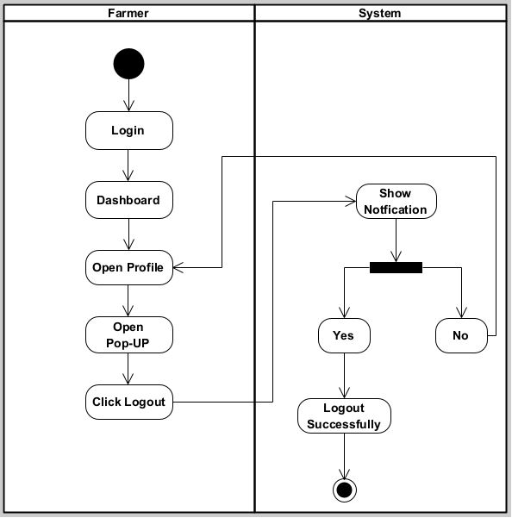

Fig 4.58 Farmer Logout Activity Diagram

4.3.4.3 Buyer’s Activity Diagrams:
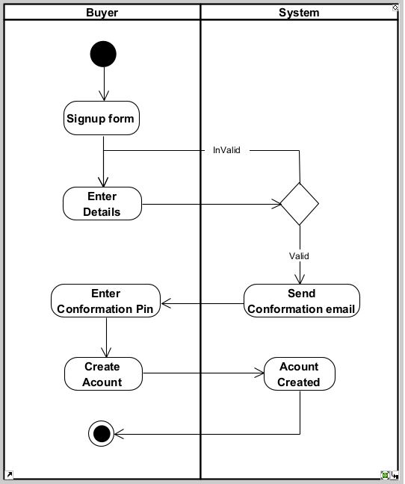

Fig 4.59 Buyer Signup Activity Diagram
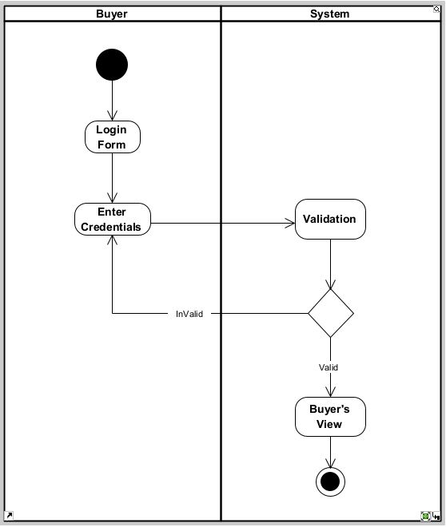

Fig 4.60 Buyer Login Activity Diagram
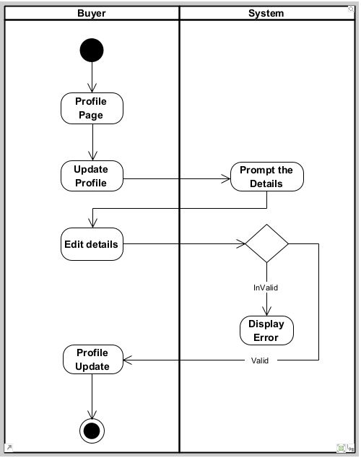

Fig 4.61 Buyer Update Profile Activity Diagram
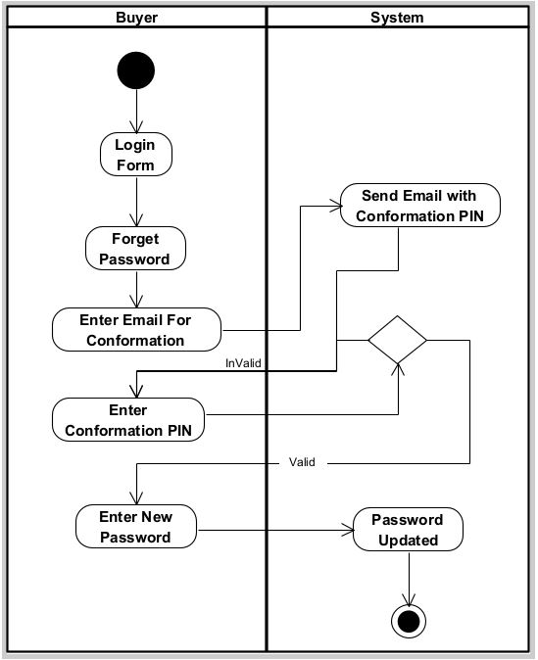

Fig 4.62 Buyer Reset Password Activity Diagram
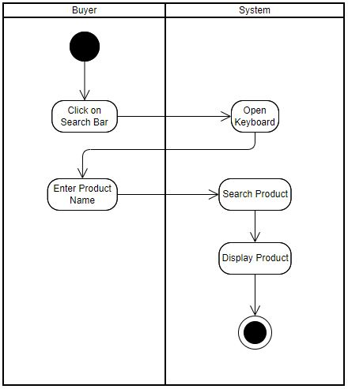

Fig 4.63 Buyer Ability to Search Activity Diagram

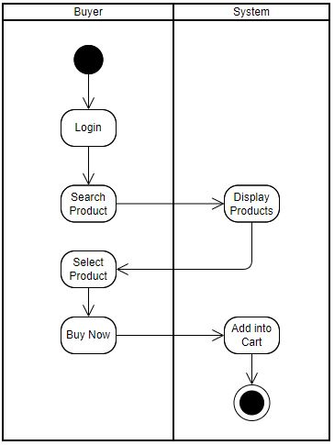

Fig 4.64 Buyer Placed Order Activity Diagram

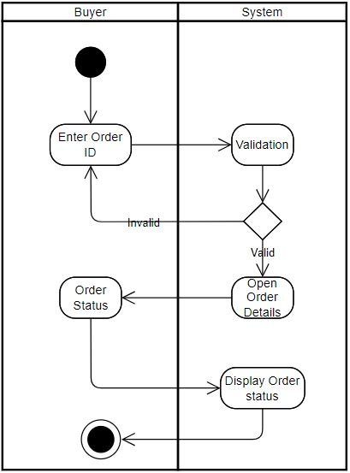

Fig 4.65 Buyer See Order Status Activity Diagram
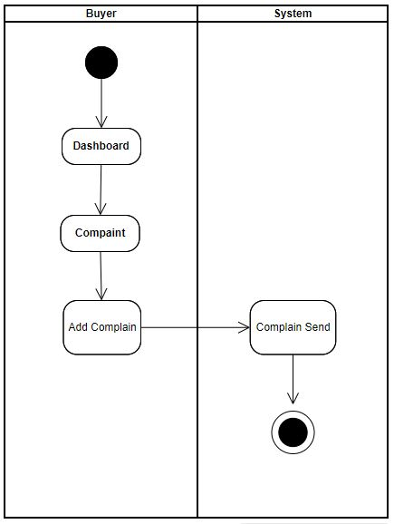

Fig 4.66 Buyer make Complaint Activity Diagram
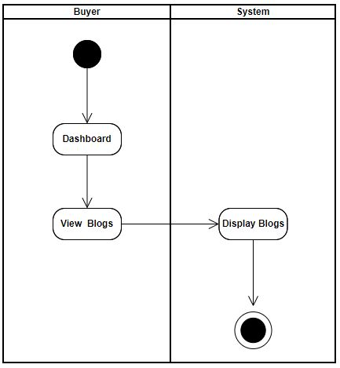

Fig 4.67 Buyer View Blogs Activity Diagram

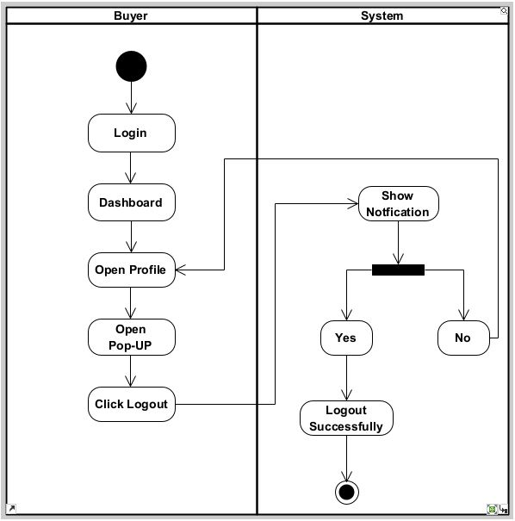

Fig 4.68 Buyer Logout Activity Diagram

4.3.5 Class Diagram

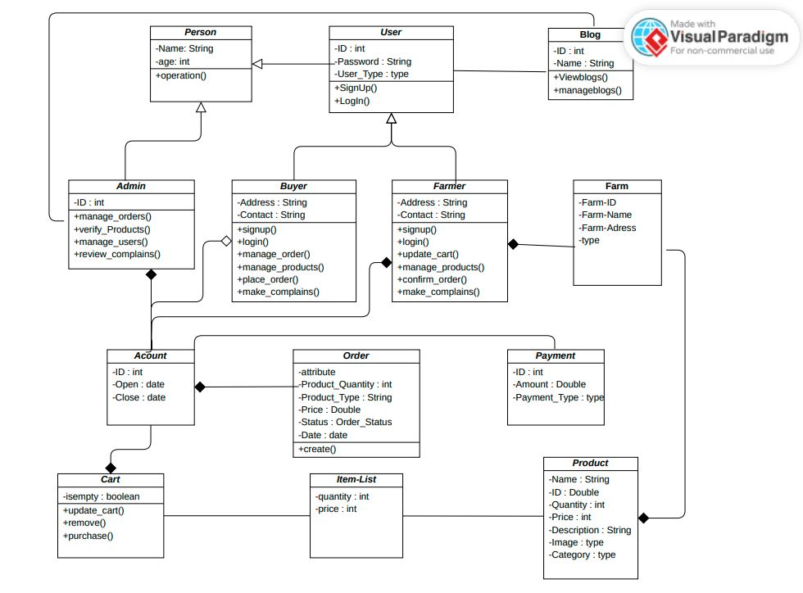

4.3.6 Entity Relationship Diagram
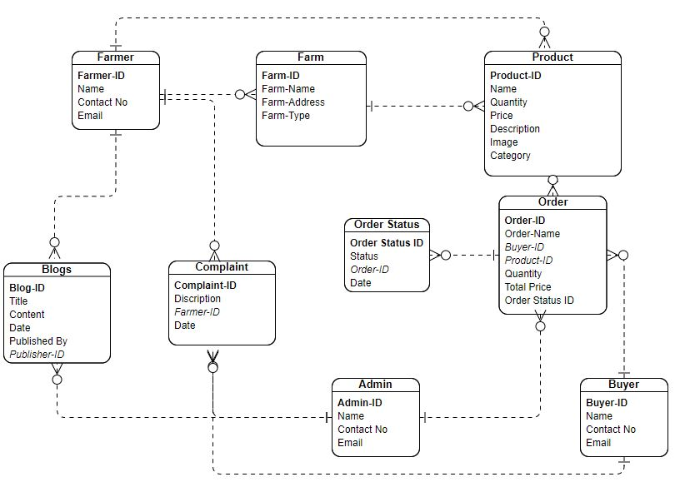

Chapter 5:Implementation

Endeavour

Team
      - Shahid Abbas
      - Ehtesham Haider

Work

WBS  # | WBS Deliverable | Activity to Complete Deliverable | Responsible Team Member(s)
1.1 | Content Control System Initial Document | Brainstorming | Shahid Abbas  Ehtesham Haider
1.2 | Evaluation & Recommendation | Discuss with Supervisor and Proposal Presentation | Shahid Abbas  Ehtesham Haider
2.1 | Literature/Market Survey | Complete research  Regarding features | Shahid Abbas  Ehtesham Haider
3.1 | Requirement Analysis | Elicitation  Writing Functional Requirements | Shahid Abbas  Ehtesham Haider
4.1 | System Design | Use case Diagram | Shahid Abbas
 |  | Architecture Diagram | Shahid Abbas
 |  | Fully Dressed Use Cases | Shahid Abbas
 |  | Activity Diagram | Shahid Abbas
 |  | Sequence Diagram | Shahid Abbas
5.1 | Implementation | Endeavour, Frameworks,  Libraries | Shahid Abbas
 |  | Flow control,  Best practices | Ehtesham Haider
6.1 | Testing and evaluation | Test cases scenario | Shahid Abbas
 |  | Test case data | Shahid Abbas
 | System Interfaces | Make Prototype | Ehtesham Haider
 | Admin and User Dashboard | Dashboard Development | Ehtesham Haider

Table

Components, Libraries, Web Services and Stubs
- HTML
- CSS
- Bootstrap
- React.js
- Node.js
- Express.js

IDE, Tools and Technologies

- VS code
- MS word
- Visual paradigm

Best Practices / Coding Standards

For Farm-2-Market we will use following coding conventions/practices:
- Code Formatting
- Commenting and Documentation
- Code Reusability
- Consistent Naming Conventions

Deployment Diagram

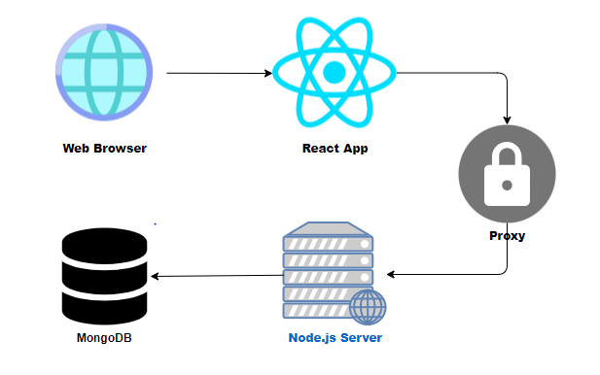

5.6 Summary

In this chapter, the basic flow control of the software been developed, its basic components, supporting libraries, development environment, required frameworks and the validation behind these selections have been discussed. The coding techniques and best practices on which the software will implement have also been discussed.

Chapter 6:
Testing and Evaluation

Chapter 6

6.1 Introduction
Software testing is a process of executing a program or application with the intent of finding software bugs and to check whether the actual results match the expected results ensuring a defect free software system. So in this chapter we will discuss testing of our admin web panel as well as application Farm-2-Market.

6.2 List of Test Scenarios
In this section we will cover all the test data and test cases of all the stakeholders involved in our system. Following are the list of all test data and test cases.

6.2.1 Test Data For Admin SignUp:

ECP:
Input::Name
Valid:
- {{a, b, c …z}, {A, B, C …Z}}
- Empty spaces are allowed with alphabet.
- 3≤character≤40
Invalid:
- Numeric value {0,1 2, 3 …9}
- Arithmetic Symbols.
- Special characters
- 3 > character and character>40
- Without alphabet spaces.
Sr# | Input | ECP | Expected Output
1 | Ali Haider | - {{a, b, c …z}, {A, B, C …Z}}  - Empty spaces are allowed with alphabet.  - 3≤character≤40 | Name Entered
2 | 0 | - Numeric value {0,1 2, 3 …9} | Re-Entered Name
3 | Ali@ | - Special characters | Re-Entered Name

ECP:
Input::Password
Valid:
- Password length >= 8
Must contain at least
- One uppercase letter
- One lowercase letter
- One Numeric character
Invalid:
- Password length < 8
- No uppercase Alphabets
- No lowercase alphabets
- No numeric character
Sr# | Input | ECP | Expected Output
1 | Ali12398 | - Password length >= 8  - One uppercase letter  - One lowercase letter  - One Numeric character | Password Entered
2 | 1233 | - Password length < 8  - No numeric character | Re-Entered Password
3 | Shahid123 | - No lowercase alphabets | Re-Entered Password

ECP:
Input::Email
Valid:
- All lowercase and Uppercase Alphabets are allowed before “@gmail.com”.
- Username must be between 6 and 30 characters long.
Invalid:
- Special characters and Arithmetic Characters before ‘@gmail.com’
- Username Characters < 6 and Username Characters > 30
Sr# | Input | ECP | Expected Output
1 | Shahid#@gamil.com | - Special characters and Arithmetic Characters before ‘@gmail.com’ | Email Incorrect
2 | 12@gamil.com | - Username Characters < 6 and Username Characters > 30 | Email Incorrect
3 | Shahid13434@gmail.com | - All lowercase and Uppercase Alphabets are allowed before “@gmail.com”.  - Username must be between 6 and 30 characters long. | Email Entered

6.2.2 Test Data For Admin Login:

ECP:
Input::Email
Valid:
- ehteshamhaider051@gmail.com
Invalid:
- Other than Valid

ECP:
Input::Password
Valid:
- Ehtesham098
Invalid:
- Other than Valid

6.2.3 Test Data Farmer SignUP:

ECP:
Input::Name
Valid:
- {{a, b, c …z}, {A, B, C …Z}}
- Empty spaces are allowed with alphabet.
- 3≤character≤40
Invalid:
- Numeric value {0,1 2, 3 …9}
- Arithmetic Symbols.
- Special characters
- 3 > character and character>40
- Without alphabet spaces.
Sr# | Input | ECP | Expected Output
1 | Ali Haider | - {{a, b, c …z}, {A, B, C …Z}}  - Empty spaces are allowed with alphabet.  - 3≤character≤40 | Name Entered
2 | 0 | - Numeric value {0,1 2, 3 …9} | Re-Entered Name
3 | Ali@ | - Special characters | Re-Entered Name

ECP:
Input::Password
Valid:
- Password length >= 8
Must contain at least
- One uppercase letter
- One lowercase letter
- One Numeric character
Invalid:
- Password length < 8
- No uppercase Alphabets
- No lowercase alphabets
- No numeric character
Sr# | Input | ECP | Expected Output
1 | Ali12398 | - Password length >= 8  - One uppercase letter  - One lowercase letter  - One Numeric character | Password Entered
2 | 1233 | - Password length < 8  - No numeric character | Re-Entered Password
3 | Shahid123 | - No lowercase alphabets | Re-Entered Password

ECP:
Input::Email
Valid:
- All lowercase and Uppercase Alphabets are allowed before “@gmail.com”.
- Username must be between 6 and 30 characters long.
Invalid:
- Special characters and Arithmetic Characters before ‘@gmail.com’
- Username Characters < 6 and Username Characters > 30
Sr# | Input | ECP | Expected Output
1 | Shahid#@gamil.com | - Special characters and Arithmetic Characters before ‘@gmail.com’ | Email Incorrect
2 | 12@gamil.com | - Username Characters < 6 and Username Characters > 30 | Email Incorrect
3 | Shahid13434@gmail.com | - All lowercase and Uppercase Alphabets are allowed before “@gmail.com”.  - Username must be between 6 and 30 characters long. | Email Entered

6.2.4 Test Data For Farmer Login:

ECP:
Input::Email
Valid:
- shahidabbas123@gmail.com
Invalid:
- Other than Valid

ECP:
Input::Password
Valid:
- Shahid098
Invalid:
- Other than Valid

6.2.5 Test Data Buyer SignUP:

ECP:
Input::Name
Valid:
- {{a, b, c …z}, {A, B, C …Z}}
- Empty spaces are allowed with alphabet.
- 3≤character≤40
Invalid:
- Numeric value {0,1 2, 3 …9}
- Arithmetic Symbols.
- Special characters
- 3 > character and character>40
- Without alphabet spaces.
Sr# | Input | ECP | Expected Output
1 | Ali Haider | - {{a, b, c …z}, {A, B, C …Z}}  - Empty spaces are allowed with alphabet.  - 3≤character≤40 | Name Entered
2 | 0 | - Numeric value {0,1 2, 3 …9} | Re-Entered Name
3 | Ali@ | - Special characters | Re-Entered Name

ECP:
Input::Password
Valid:
- Password length >= 8
Must contain at least
- One uppercase letter
- One lowercase letter
- One Numeric character
Invalid:
- Password length < 8
- No uppercase Alphabets
- No lowercase alphabets
- No numeric character
Sr# | Input | ECP | Expected Output
1 | Ali12398 | - Password length >= 8  - One uppercase letter  - One lowercase letter  - One Numeric character | Password Entered
2 | 1233 | - Password length < 8  - No numeric character | Re-Entered Password
3 | Shahid123 | - No lowercase alphabets | Re-Entered Password

ECP:
Input::Email
Valid:
- All lowercase and Uppercase Alphabets are allowed before “@gmail.com”.
- Username must be between 6 and 30 characters long.
Invalid:
- Special characters and Arithmetic Characters before ‘@gmail.com’
- Username Characters < 6 and Username Characters > 30
Sr# | Input | ECP | Expected Output
1 | Shahid#@gamil.com | - Special characters and Arithmetic Characters before ‘@gmail.com’ | Email Incorrect
2 | 12@gamil.com | - Username Characters < 6 and Username Characters > 30 | Email Incorrect
3 | Shahid13434@gmail.com | - All lowercase and Uppercase Alphabets are allowed before “@gmail.com”.  - Username must be between 6 and 30 characters long. | Email Entered

6.2.6 Test Data For Buyer Login:

ECP:
Input::Email
Valid:
- alihaider051@gmail.com
Invalid:
- Other than Valid

ECP:
Input::Password
Valid:
- Ali1121098
Invalid:
- Other than Valid

Chapter 7:
Conclusion and Outlook

Chapter 7

7.1 Introduction:
In this chapter, we would like to conclude our work done on Farm-2-Market. This Section of the document briefly describes the work done till now and the achievements which are made so far in the development of our application, furthermore this section of the document will also describe the brief work on the future and further improvements which are to be done in the application.

7.2 Achievements and Improvements:
The major achievement in our view is the level of understanding that we as a team developed during the course of development. We as a team have learned many things related to the field of Web Development and have gathered lot of knowledge on it. We have improved our concepts, knowledge and skills in Web development. We have learnt to work in a team and to face all the overcome all the hurdles within given period of time. We have learnt different types of libraries who played a vital role in our project development. After development of this project, we will be capable of building any similar product.

7.3 Critical Review:
The target of the Farm-2-Market Portal project is to create a centralized online platform that addresses the inefficiencies and limitations of traditional agricultural trade. The aim is to connect farmers and buyers, overcoming geographical barriers, limited market visibility, and restricted access to potential buyers. The project seeks to provide a comprehensive solution by enabling farmers to showcase their products and allowing buyers to easily discover and purchase farm products. The ultimate goal is to streamline agricultural trade, increase market access for farmers, and provide a convenient purchasing experience for buyers.

7.4 Outlook:
